**Human Computer Interaction CS411**

February 2, 2021

|  |  |
| --- | --- |
| Faizan Abid | 17B-057-SE |
| Riffat Siddiqui | 17B-044-SE |
| Komal Tahir | 17B-031-SE |
| Ibad Hashmi | 17B-022-SE |



Sir Syed Shahrooz Shamim

Contents

1. Introduction: 4

1.1 Problem: 4

1.2 Target Users: 4

1.3 Solution: 5

2 Task and User Analysis 5

2.1 User Analysis 5

2.1.1 Stakeholders: 5

2.2 TASK ANALYSIS 7

2.2.1 LIST OF TASKS: 7

2.2.2 TASK SCENARIO-1 8

2.2.3 TASK SCENARIO-2 9

2.3 Usability Requirements: 10

3 Conceptual Design 11

3.1 Use cases identified 11

3.2 Metaphors 12

3.3 Content diagram: 14

4 Design Sketches 15

4.1 Design Alternatives: 17

4.2 Preliminary Design: 19

4.3 Story Boarding: 21

5 PROTOTYPING- 29

5.1 PAPER BASED 29

6 PROTOTYPING 34

6.1 COMPUTER BASED 34

7 Heuristic Evaluation & Prototype Revision #1: 38

7.1 Evaluation Process: 39

7.1.1 Website Name: Corona Form 45

7.1.2 Findings and Recommendations: 47

Conclusion 48

8 User Testing & Prototype Revision #2: 49

8.1 Usability Test Report 49

8.2 Focus of Evaluation: 50

8.2.1 Testing Setup, Moderation & Post-Task Questions: 51

8.2.2 Post-Test Questions: 51

8.2.3 Finding and recommendation: 52

8.3 Updated Prototype 53

9 Roles and Tasks 56

# Introduction:

## Problem:

COVID 19 have affected not only small but large businesses too, in which restaurants have a huge role. The place where people come to enjoy the meal, attend meetings and have lunch, eat dinner with their friends and family after a tiring day. When all of this cannot happen without any precautions and social distancing which is now have become very common due to COVID because anyone can be affected by coronavirus when not taking safety precautions. When there is still smart lockdown in cities, restaurants are still open for dine in but for limited time. People start to rush into restaurants at different times and crowd throngs the restaurants which is then difficult for restaurants to manage them specially in COVID times. Customers need to wait for long hours for their turn and the time they are waiting for the restaurant timings are closed. Even sometimes the restaurant runs out of some item the customer wants to order. The policy during corona times is that restaurants cannot gather huge crowds because they also have to maintain social distancing between the tables to avoid any contact of customers with other customers. The exposure risk is high when there is high traffic in restaurants.

## Target Users:

**1.  Restaurant owners:**

* Register Restaurant.
* Register/login.
* Retrieve Guest list.
* Provide customers with space available.
* Download brochure.
* Receive QR code.

**2.  Customers:**

* Fill provided form by restaurants.
* Scan QR code.
* Receive confirmation email.

## Solution:

The solution for not causing high traffic in restaurants is that they will first have to register on the website and then will be provided with a form. The form is for the guests to fill in their details, when this is done the customer will see a screen of at what time you filled the form and will also receive a mail. Customers have to show this screen or email to the staff or host of the restaurant so that they can book a table for themselves. By filling out this form the restaurant will also have the details of their guest lists. By providing this form to customers and then reserving their table in accordance with when the table is available will lower the crowd at specific times. It will be easy for the staff to manage the customers and provide them with their best services as they will not have to handle all the throng.

# Task and User Analysis

## User Analysis

### **Stakeholders:**

* **Primary stakeholder (Restaurant owner, Admin):**

The Admin who manages all the guest and reservation of the restaurant.

**Goals:**

* + - Register Restaurant.
    - Register/login.
    - Retrieve Guest list.
    - Provide customers with space available.
    - Download brochure.

**Personas:**

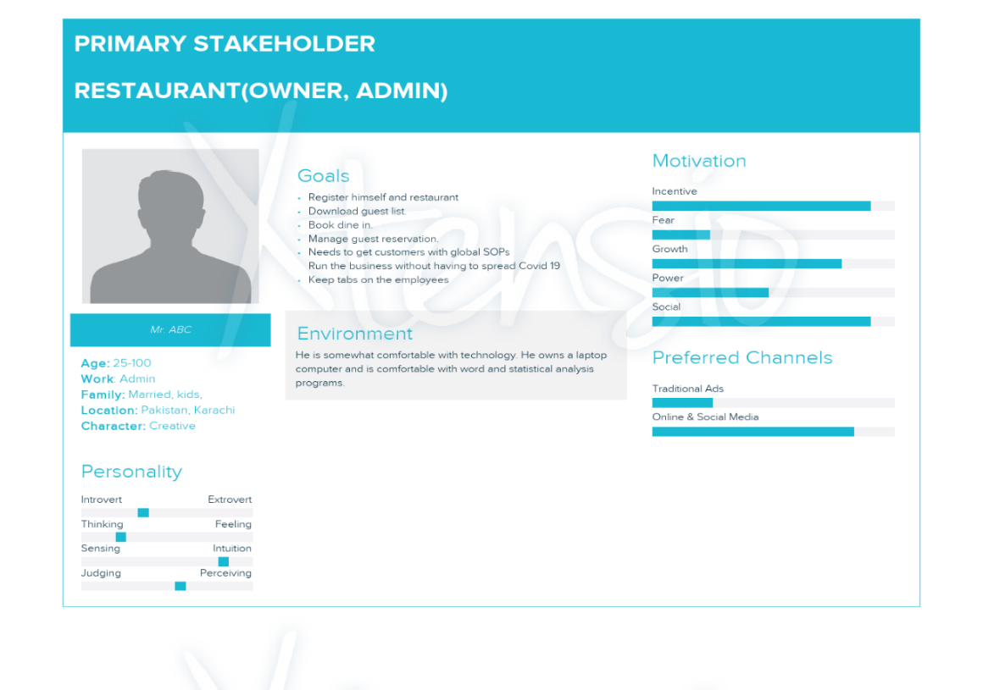

* **Secondary stakeholder (Guest):**

The guest who fills form for the reservation of dine in

**Goals:**

* + - Fill provided form.
    - Scan QR code
    - Receive confirmation

**Persona:**

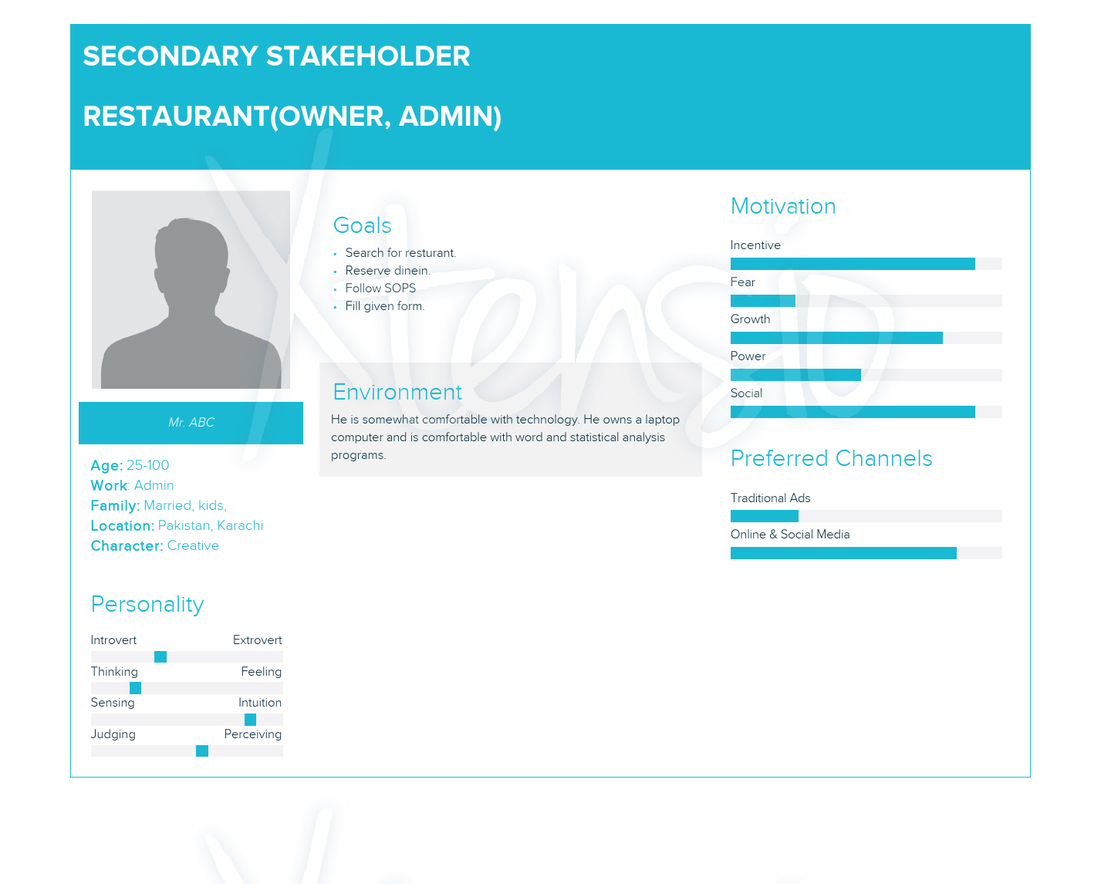

## TASK ANALYSIS

The primary user identified is the restaurant owner. Other could be the customer that would want to din in rather than delivery. The restaurant owner would be the stakeholder that would want to run his/her business even in the pandemic.

### LIST OF TASKS:

**PRIMARY ACTOR (RESTURANT ADMIN):**

1. Registration / Login:
2. Registration for admin
3. Registration for restaurant.
4. Retrieve guest list
5. Edit profile
6. Admin profile
7. Restaurant profile.

**SECONDARY ACTOR (CUSTOMER):**

1. Scan QR Code.
2. Fill form for reservation.
3. Contact us.

### **TASK SCENARIO-1**

Due to **COVID** because anyone can be affected by coronavirus when not taking safety precautions. There is still smart lockdown in cities, restaurants are still open for dine in but for limited time. People start to rush into restaurants at different times and crowd throngs the restaurants which is then difficult for restaurants to manage them especially in COVID times. Customers need to wait for long hours for their turn and the time they are waiting for the restaurant timings are closed. So, Restaurant owner need a virtual platform where he manage all the government policies (cannot gather huge crowd, maintain social distancing between the tables) and maintain SOP’S in restaurant.

**Solution:** We need to create a platform where restaurants and customers are connected with one another to take care of the above issue.

**Steps for the User Perspective:**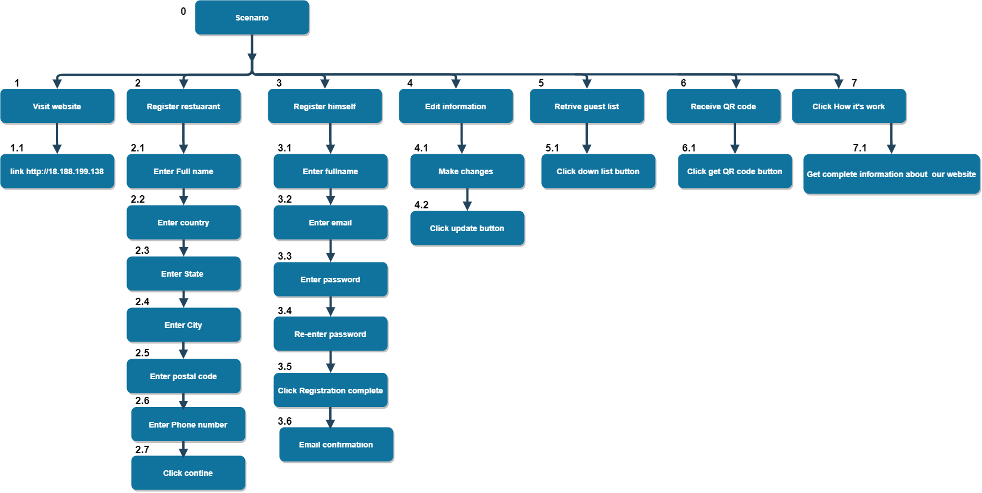

Hierarchical view of steps fig #1.

**Explanation:**

In the fig 1. Our primary stakeholders (Restaurant proprietor, administrator) need to enroll on our site first. At that point, he enrolls himself as the owner of the restaurant. After registration, he got a QR code that is unique, for this he can insert the QR code into a different platform like (Website, socializing app). If later he needs to change any information about the company he can change by simply click on edit information. He would now be able to see the list of guest who applies for the reservation and send an email to the guest for reservation is possible or not.

### **TASK SCENARIO-2**

Due to Covid the user cannot make reservations personally or reach out to the restaurant, a platform from which the restaurant and the customer interact with each other must be enforced. As covid can infect many people, therefor the customer would not want to dine in such a restaurant which does not ensure safety of others. The users must confirm and accept to follow the SOPs for themselves and encourage others as well. People start to rush into restaurants at different times and crowd through the restaurants which would be difficult to manage as social distancing is a must.

**Solution:** We need to create a platform where restaurants and customers are connected with one another to take care of the above issue.

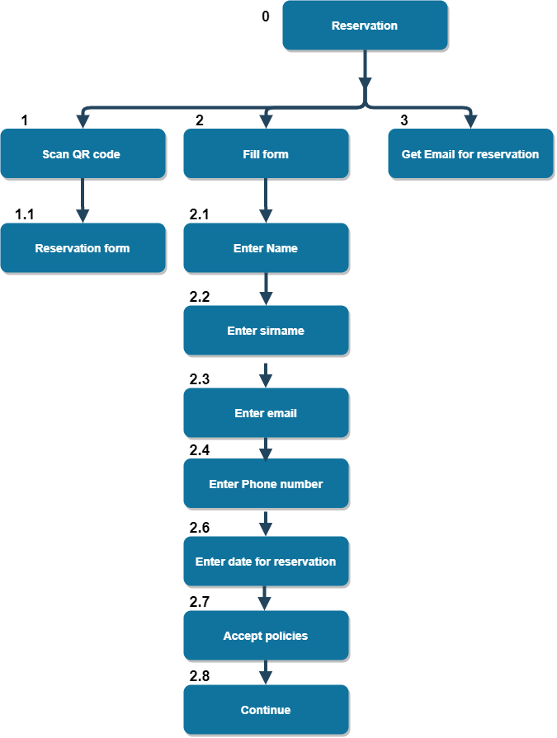**Steps for the User Perspective:**

Hierarchical view of steps fig #2

**Explanation:**

In the fig 1. Our secondary stakeholders (User), He need to scan QR code for reservation. And then the form will appear after fill up the form. He got email from restaurant for reservation.

## Usability Requirements:

Some usability requirements that apply in our application are:

* **Usability:**

The system is easy to understand and every design is well suited for its purpose. The processes of the application system is automated. The system is supportive and provides guide to the Restaurant owner on how the QR code works and where to download it

* **Performance:**

The system is robust and provide an interrupt and error free communication to user. The system response to the owner when he/she downloads the form.

* **Reliability:**

The application provides a reliable solution to customers so that they can reserve their table before entering the restaurant and they will not have to wait.

* **Security:**

The application is secure and the customer’s data will not be shared with any other except the owner of the restaurant where his data is saved for reservations. The data customer provides is confidential as their data will be stored in compliance with the GDPR and automatically deleted after 30 days.

* **Efficiency:**

The resources used for this is system to be made is efficient. We have achieved Optimum efficiency in our system. In downloading the QR code there will be no delay as well.

* **Storage:**

Customer’s data is stored in database for only 30 days and it will be deleted after then. There will be no risk of losing data as well because restaurant owner can download the guest list which is in excel sheet and it cannot be deleted by its own, so guest record will be saved every time owner download the list.

* **Reusable:**

The form owner download or can retrieve from the QR code can be reused by customers. Owner can also put that form in their restaurants door or put it on websites so it is easily accessible for them and portable too.

* **Environmental:**

The system is eco-friendly as no use of paper and in corona times it is specially not right to interact with people so online form is available for customers to book their reservations.

* **Manageability:**

It is easy for restaurants to manage the customers and not create crowd.

* **Supportability:**

This system is remotely accessible for customers as they can fill the form anywhere and any time

# **Conceptual Design**

## Use cases identified

**Restaurant Owner:**

* **Register restaurant:** The restaurant owner would register the restaurant and they would be able to proceed to the next step.
* **Retrieve guests list**: the owner would be able to access the guest list generated by the system when the users would fill in their reservations.
* **Download brochure**: the brochure would have details of the restaurant with the links, QR code and the restaurant details. Restaurant owner can also hang this on their place
* **Receive QR code:** the QR would be generated by the system for the restaurant owner.

**Customer:**

* **Fills Form:** the customer will fill the form providing the details of the reservation such as name and other details.
* **Scan QR Code:** user can scan the QR code to receive the details of restaurant and also for confirmation.
* **Receive Emails:** the user will also receive the email for the confirmation of their reservation.

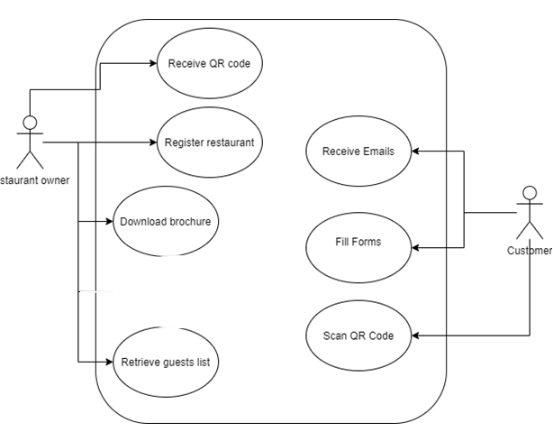

## Metaphors

**Login:**

Text boxes, input field, password field, forget password link.

**Register:**

Input fields, text fields, number fields

Dropdown is another alternative for selecting the country.

**Main page:**

The main page has buttons from which the user would be able to click and navigate to the different functionality.

The button would be to get the QR code to retrieve the guest list how the application works. The main page would also have the guest link from which the guests would fill the details for their reservation which would be used to generate guests list or QR code.

The alternative that could be used is to give a button for filling the form instead of link but link is better as the user that would want to fill the form could be anytime or anywhere so the form that would open should be independent.

**Guest form:**

The input fields for name, full name, email and phone would be provided to the user from which he/she would fill out the form. Another would be a confirmation radio button for which the user would click or select to confirm he/she doesn’t show any symptoms or COVID or he is not currently infected.

**Scan QR code:**

The QR code generated would be downloaded as a pdf file so that the user would have the details and can scan the QR code. The options for this would be to click on a button or a link to get the QR code or the user can scan the QR code from any QR scanner and show it to the restaurant for confirmation.

**Guest List:**

The guest list would be generated and received by the restaurant owner. This options for this would be the owner can have an excel sheet generated or the result of reservation would be showed on a grid view.

## Content diagram:

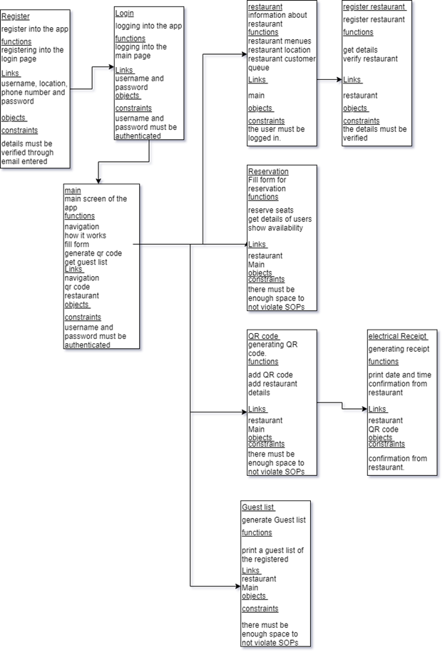

# A screenshot of a computer Description automatically generated with medium confidenceDesign Sketches

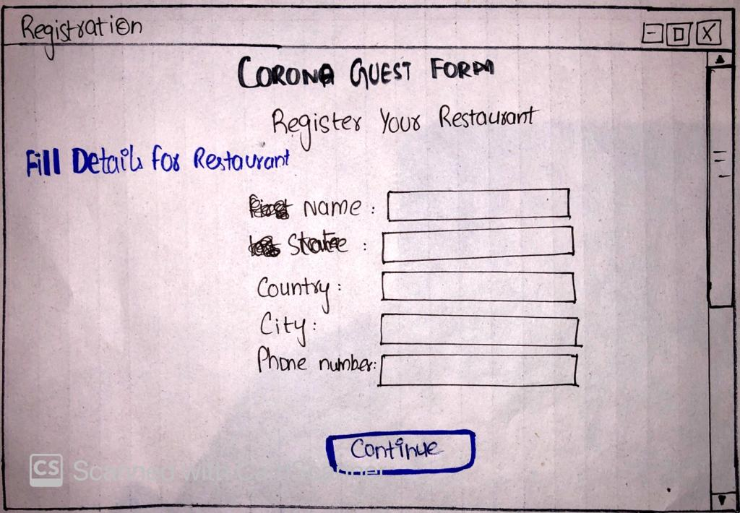

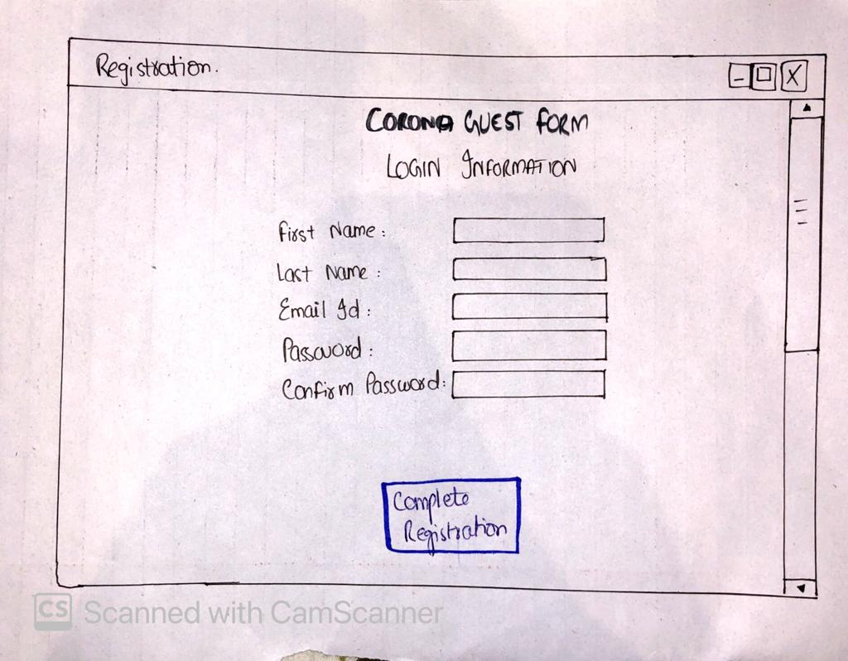

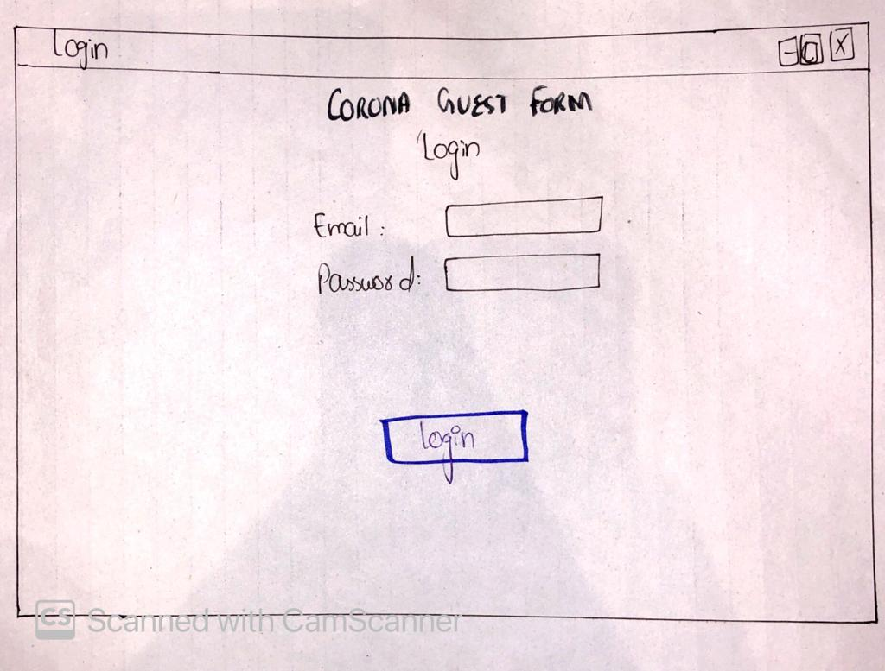

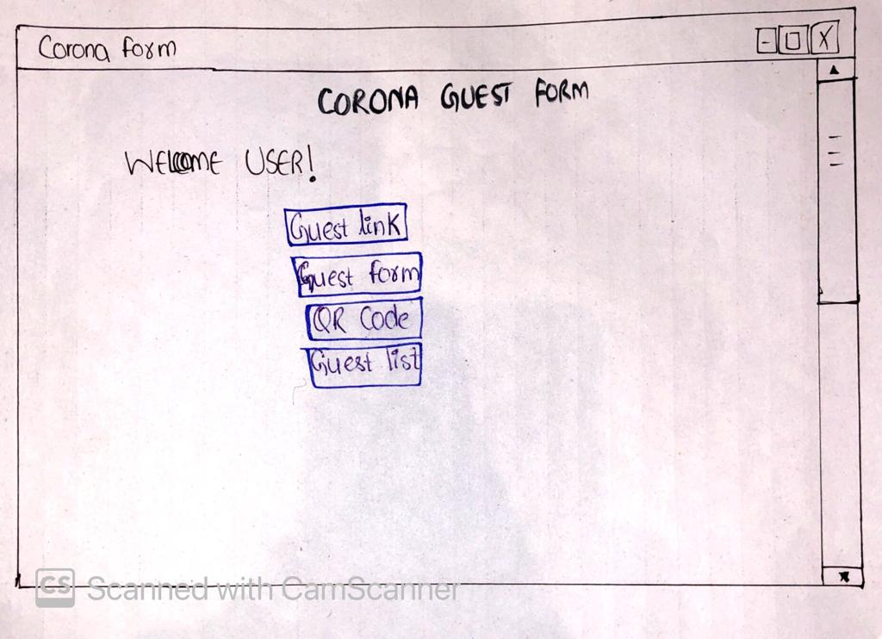

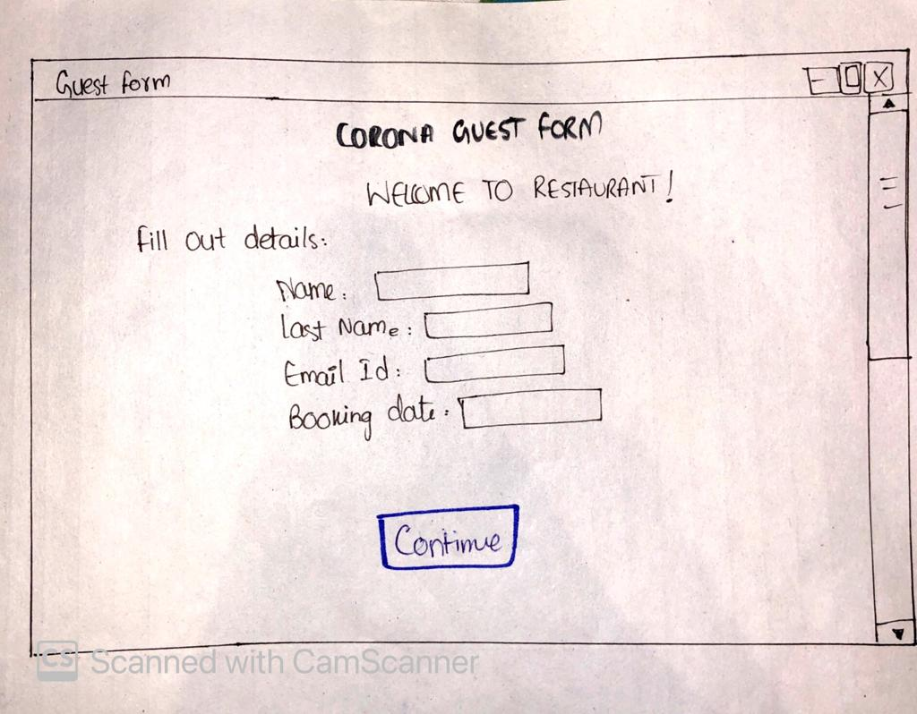

The Sketch I selected which is most promising to focus on is this.

## Design Alternatives:

The design alternatives for the above sketch are:

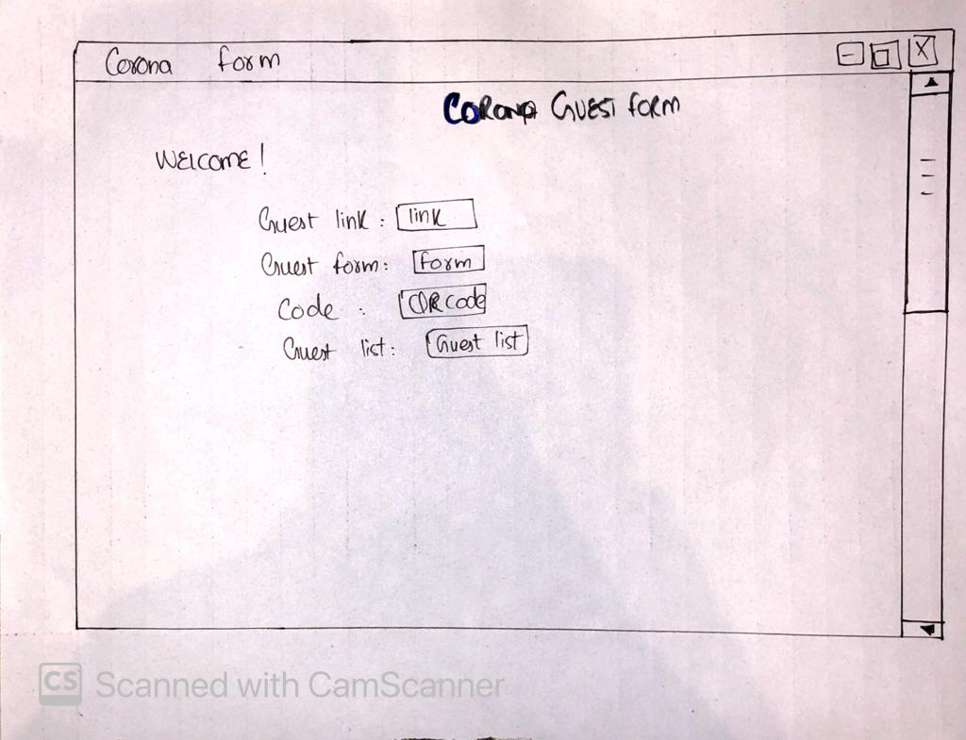

1. 

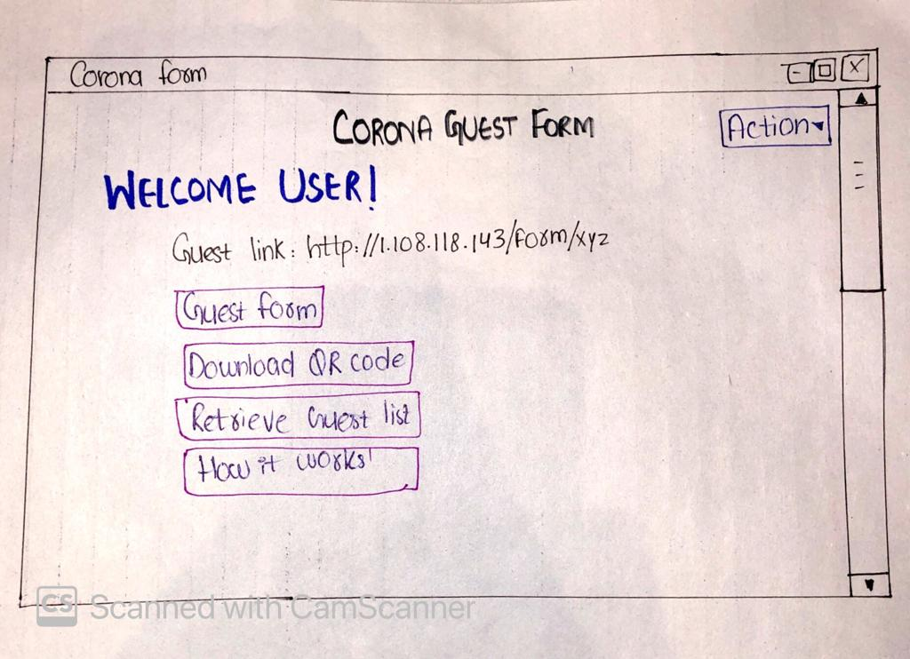

**Final Design:**

I have finalized this design because according to T3 metaphors most of the interaction for our interface are performed in this and it is the most promising to focus on as a user will interact with this interface mostly to get the form, QR code and guest lists and the information of how this works.



## Preliminary Design:



The above is the preliminary design we selected. When a restaurant owner register through registration form, the above interface will be shown to the owner to perform some specific tasks like providing them with a guest form link.

**Guest Form:**



When clicking on the “QR code” the code for the form will be downloaded.

“Retrieving guest list” will download the guest list who have filled the form and it will show in an Excel Sheet to the user.

A screen of how it works will be shown to user.

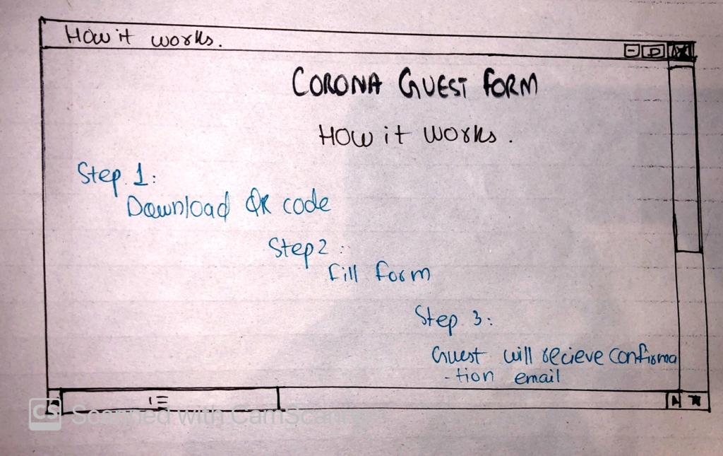

The “Action” button will provide the user a menu to perform actions like going back to home page, Edit Restaurant Information, Edit Login information and logout options.

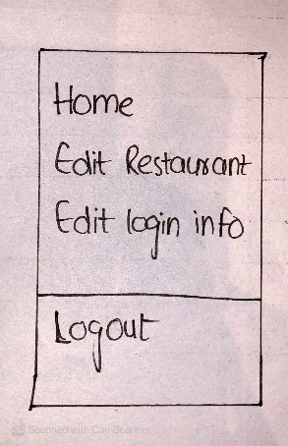

## Story Boarding:



**For Restaurant Owner:**

It is important for the restaurant owner to first register himself/herself to be on the above interface which would be the main page he will be shown for his restaurant after registering. The rough sketch for registration interface would be look like this:





Then the preliminary design will show to the restaurant owner.



When the Owner wants a form link he/she will click there to copy this link

And if owner wants to open the page form after clicking on “Guest Form” the below page will appear:



The owner will provide this form to the guests at restaurant.



By clicking on “Download QR code” a code will be downloaded so that it can be share to customers and it can also be put on restaurant doors for customers.

Owner then can retrieve the lists of guests who has filled the form and it will be shown in an excel sheet.

A guide to how the QR code will work for guests and how they will fill the form will be shown here as below:





Action button will show a menu of what actions owner can perform like go to home, edit and logout as shown:



Home button will bring back you to the main page that is the preliminary design we selected.

This will logout owners account and he/she will have to login again.

If owner wants to make any changes into restaurant detail this action will take owner to the page where you can edit details of your restaurant and below screen would be displayed:

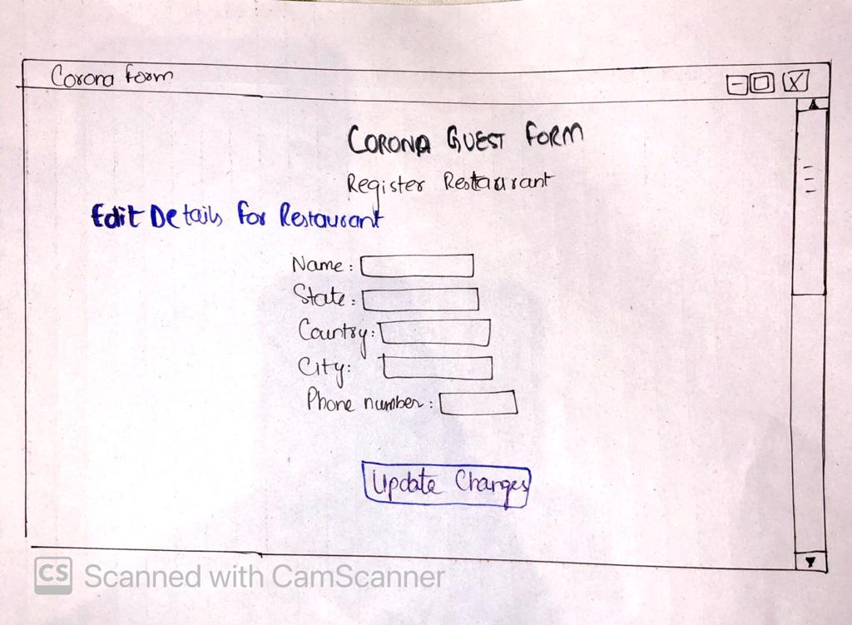

After filling the input owner can click on the “update Changes” button and edit details for restaurant

 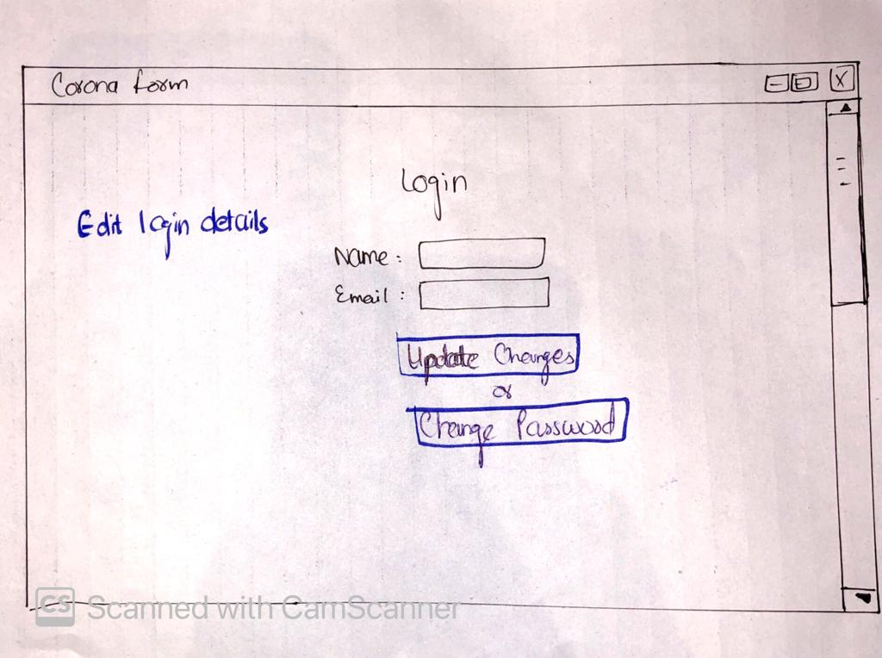

When the input field is completed owner can edit login details by clicking on “update Changes” button or even can change password.

**For Customers:**



Restaurant owner will provide the Guest form to customers and below interface would be only shown to customers for booking the seat.



when input is filled customer will click the continue button and the email will be send to customers for confirmation and this screen will also appear after clicking “Continue”

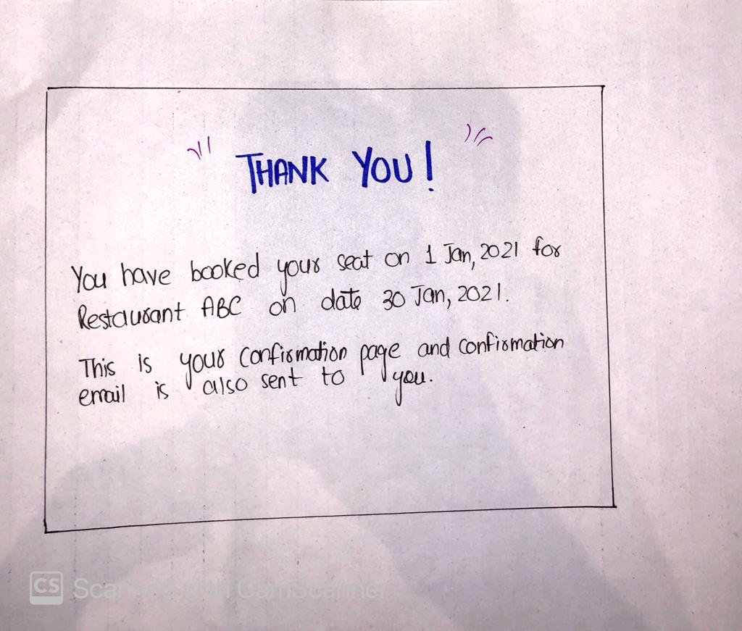

# PROTOTYPING-

## PAPER BASED

**Restaurant (Owner, Admin) perspective:**

* **REGISTRATION / LOGIN:**

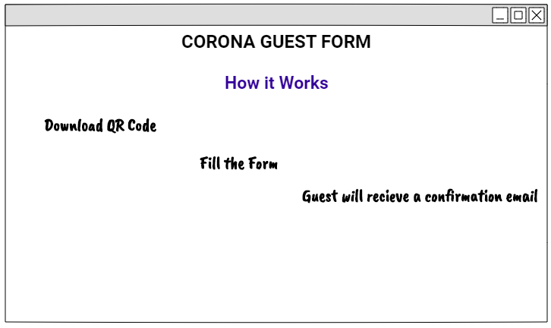

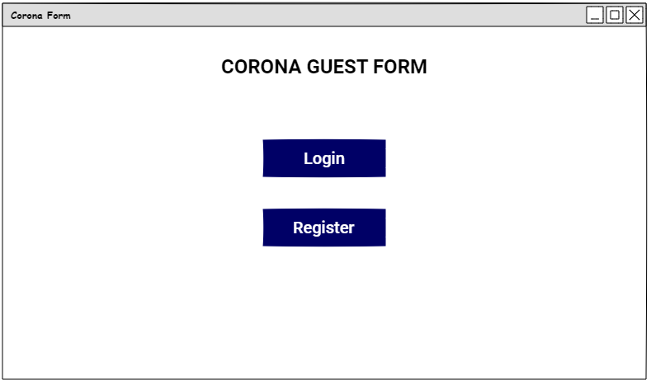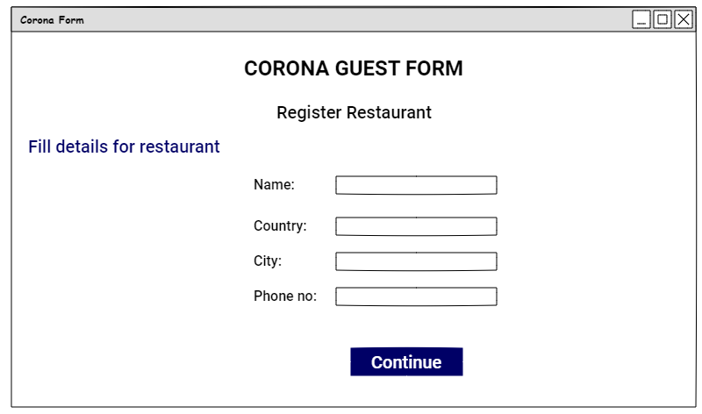

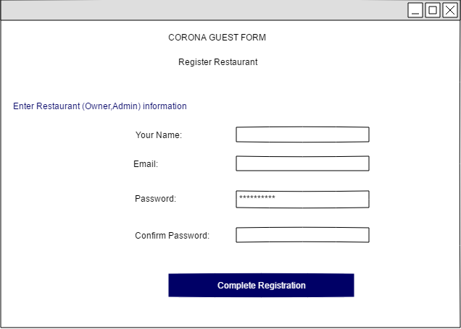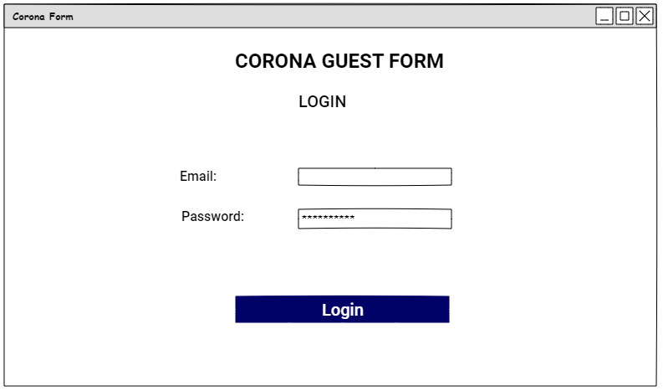

* **MAIN SCREEN AFTER REGISTRATION/LOGIN:**

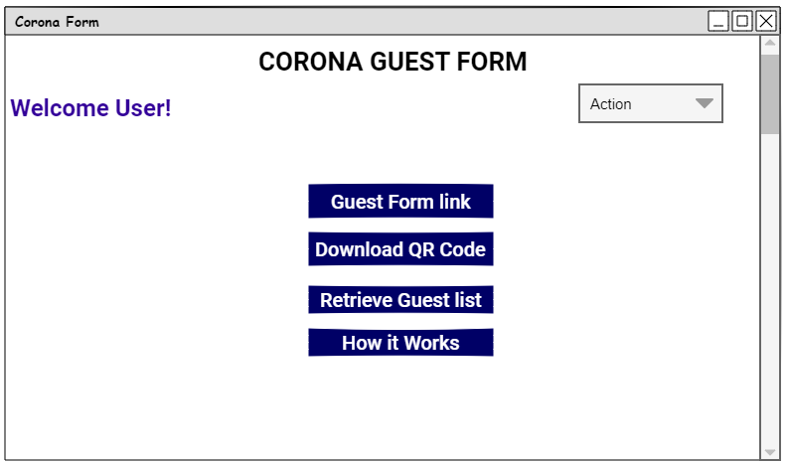

* **Edit detail for restaurant:**

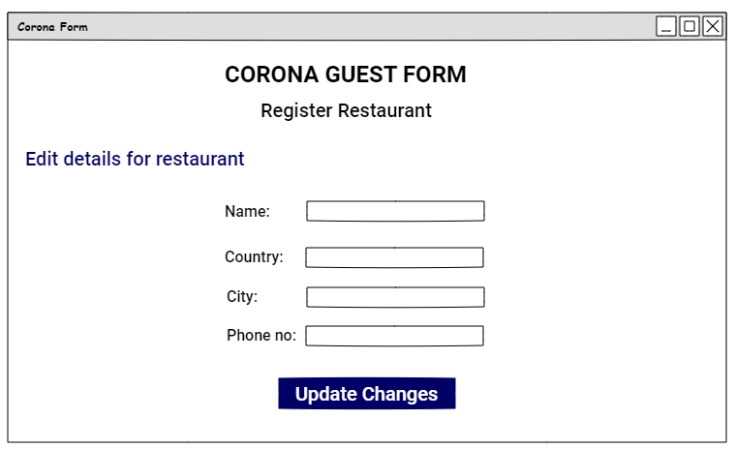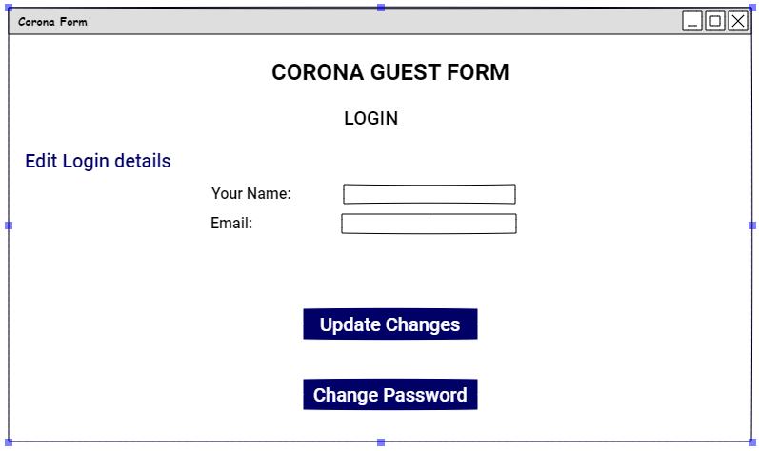

**Customer’s perspective:**

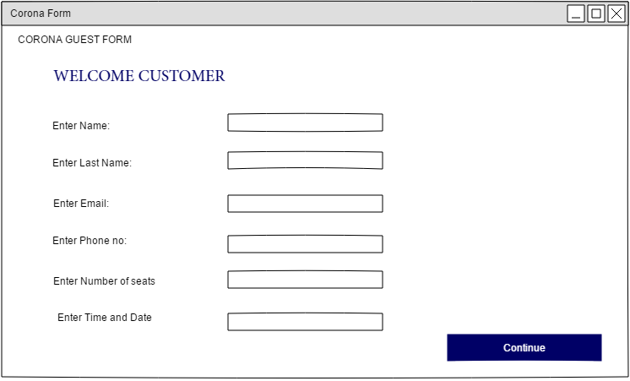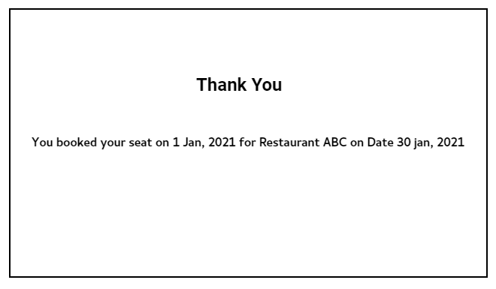

**EXECUTIVE SUMMARY:**

Due to COVID, restaurants are still open for dine in but for limited time. People start to rush into restaurants at different times and crowd throngs the restaurants which is then difficult for restaurants to manage them especially in COVID times. Customers need to wait for long hours for their turn .Thus, by utilizing technology we overcome the problem (crowd and sops maintenance).

**SCOPE:**

Scope of this project is to build a website for reservation tables for restaurant. User can allowed to take reservation quickly and easily. These reservation are under user’s control. The user can choose reservation as per their preference of location and time. The restaurant admin doesn’t need to maintain a guest book anymore. Admin can simply reply to the user by email. This method also makes it easy to change the status of reservation. Time management become simple.

**OUR STAKEHOLDERS:**

* + **Primary stakeholder (Restaurant owner, Admin):**

The Admin who manages all the guest and reservation of the restaurant.

* + **Secondary stakeholder (Guest):**

The guest who fills form for the reservation of dine in

**TOTAL USECASE:**

1.  **Restaurant owners:**

* Register Restaurant.
* Register/login.
* Retrieve Guest list.
* Provide customers with space available.
* Download brochure.
* Receive QR code.

2.  **Customers:**

* Fill provided form by restaurants.
* Scan QR code.
* Receive confirmation email.

**TASK:**

* Imagine you are restaurant owner and need a website for hotel dine in reservation so, you have a sample prototypes that how your website working. Now you have to check that prototypes meet all the requirement.
* Imagine you are user and need to reserve dine in. You need check that prototypes meet all the requirement of reservation form.

**GOAL:**

* Register your restaurant in our system.
* Fill the form of user reservation.

**PARTICIPANT PROFILES:**

Participant which are involve in prototype testing.

|  |  |  |  |  |  |
| --- | --- | --- | --- | --- | --- |
| **Users** | **Age** | **Gender** | **Education** | **Occupation** | **Place** |
| User 1 | 21 | Male | Undergraduate | Freelancer | Online meeting |
| User 2 | 24 | Female | Masters | Web developer | Online meeting |
| User 3 | 20 | Male | Undergraduate | Web developer | Online meeting |

**RESULTS:**

As the result of the paper-based prototypes, we clear lot of confusion that we are facing and get lot off feedback which may help to build the interface more clearly and efficiently.

**SUMMARY OF INSIGHTS:**

* **FEED BACK:**
* User like the general look of our website.
* User found attractive to fill the reservation form by QR code.
* This software easily to maintain SOPs in restaurant by just filling form by customer.
* **GENERAL SUGGESTIONS:**
* User want another way to contact other than the reservation process for some user felt that was too big of a first step.
* Guest list must be on excel sheet for easily maintenance.
* **USER EXPERIENCE SUGGESTIONS:**
* User suggested having a better explanation of the website in the banner of the homepage.
* Final after filling form must show no. of seats book with restaurant name, address on email that user receive.
* “How it’s work” section must contain all possible steps customer and restaurant admin.
* Customer form must contain, policies for COVID and user have to confirm that policies otherwise no further process.

# PROTOTYPING

## COMPUTER BASED

* **WEBSITE LOOK:**

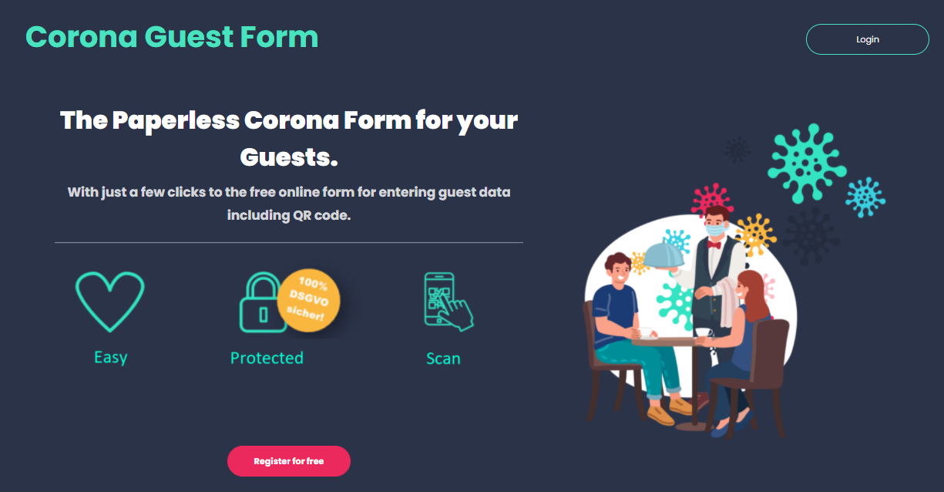

**Restaurant (Owner, Admin) perspective:**

* **REGISTRATION / LOGIN:**

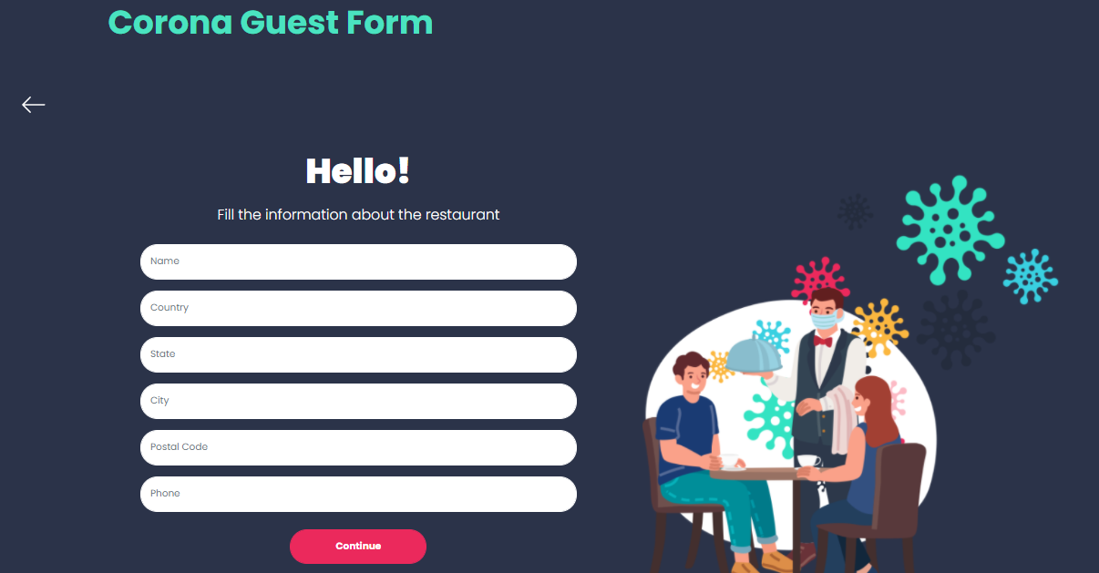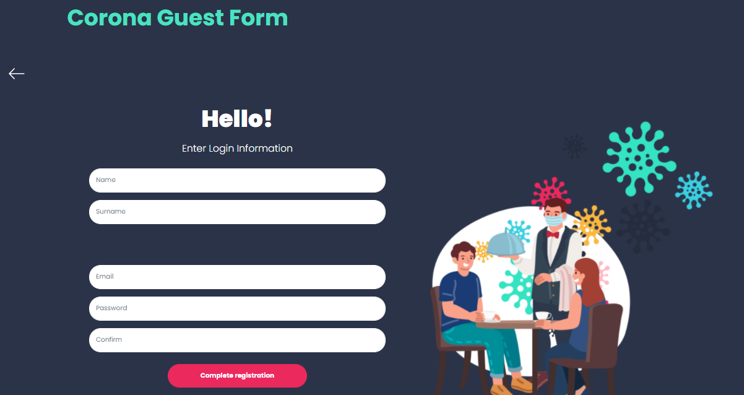

**MAIN SCREEN AFTER REGISTRATION/LOGIN:**

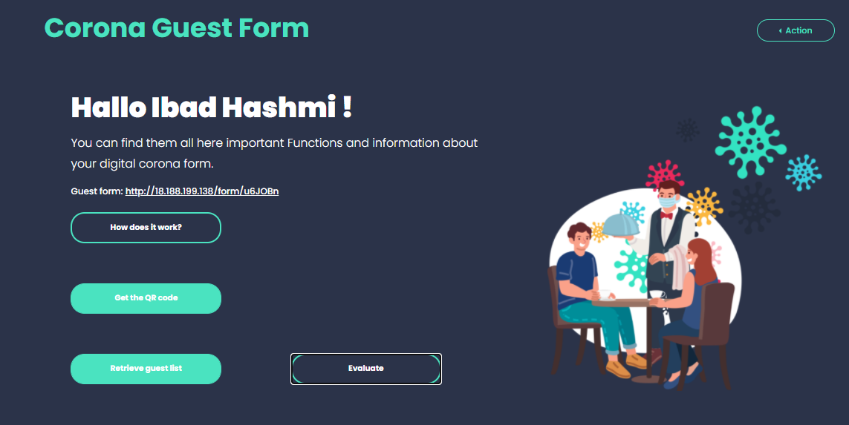

* **Edit detail for restaurant:**

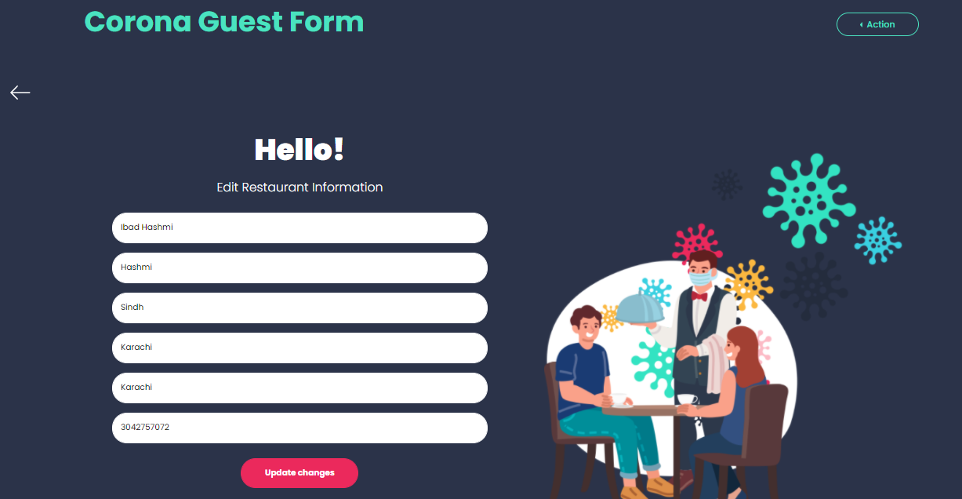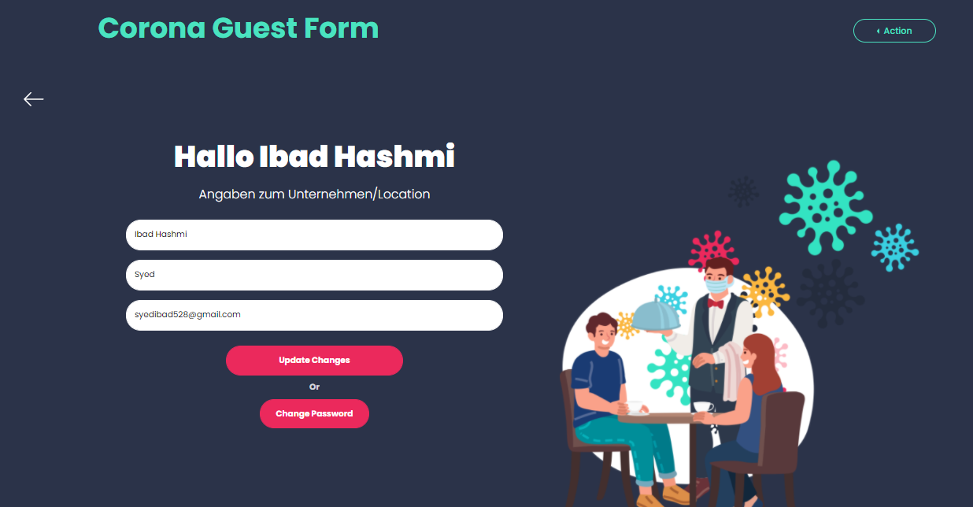

* **GUEST LIST:** 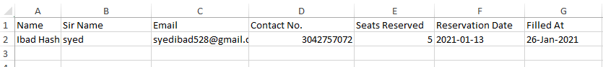
* **HOW IT’S WORK SECTION:**

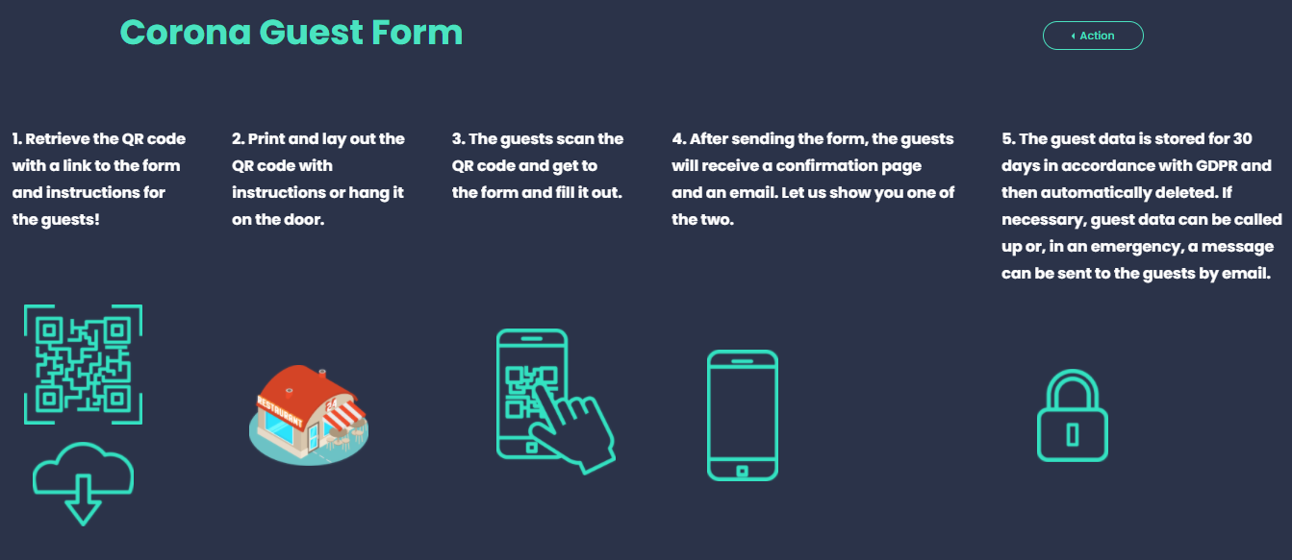

**Customer’s perspective:**

* **QR CODE FOR SPECIFIC RESTAURANT:**

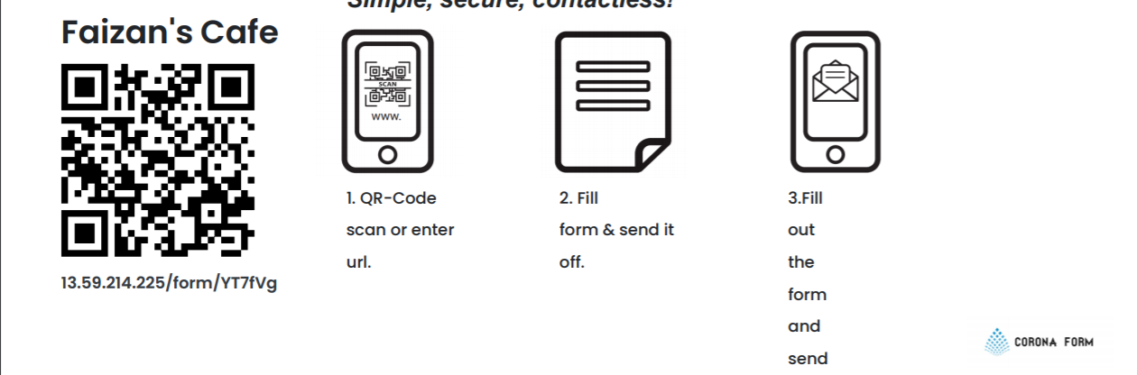

* **QR CODE FOR SPECIFIC RESTAURANT:**

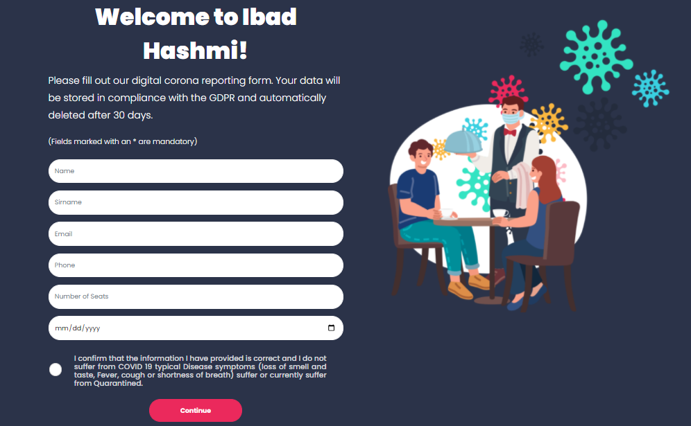

* **EMAIL RECEIVED AFTER FORM FILL BY USER:**

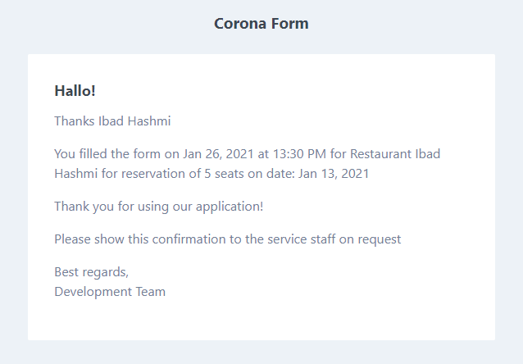

# Heuristic Evaluation & Prototype Revision #1:

**Executive Summary:**

For this report, we conducted heuristic evaluations of **CORONA FORM** Heuristic evaluations allow us to analyze the usability and functionality of the site in a standardized way. We performed individual heuristic evaluations and then met together to discuss and combine our results. The system was evaluated and ranked according to user testing heuristics and severity rating scale of 0-3. After discussing our noted usability issues, we prioritized our findings by severity and developed the following series of findings and recommendation.

**Introduction:**

Due to COVID, restaurants are still open for dine in but for limited time. People start to rush into restaurants at different times and crowd throngs the restaurants which is then difficult for restaurants to manage them especially in COVID times. Customers need to wait for long hours for their turn .Thus, by utilizing technology we overcome the problem (crowd and sops maintenance).

**Focus of Evaluation:**

To first start off, we narrowed down what site UI screen. We wanted to evaluate. Looking at the site’s main functions, we focused on evaluating **CORONA FORM** ability to create better and customize screens. We also considered our client’s request by making UI.

**Methods:**

Heuristic evaluations allow us to better understand our client’s system, quickly identify minor and major usability issues, and alert the client to usability issues they may be unaware of. By conducting both individual and group heuristic evaluations, we can ensure that we provide a thorough evaluation of the site. After evaluating the site, we combined and discussed our results and developed a series of findings and recommendations.

## Evaluation Process:

Each group member and class fellow conducted an individual heuristic evaluation of CORONA. While performing the evaluations, each member took notes on the site’s usability successes and failures and ranked the severity of each noted usability finding (see Appendix). For our severity scale, we provide user evaluation material at http://13.59.214.225/

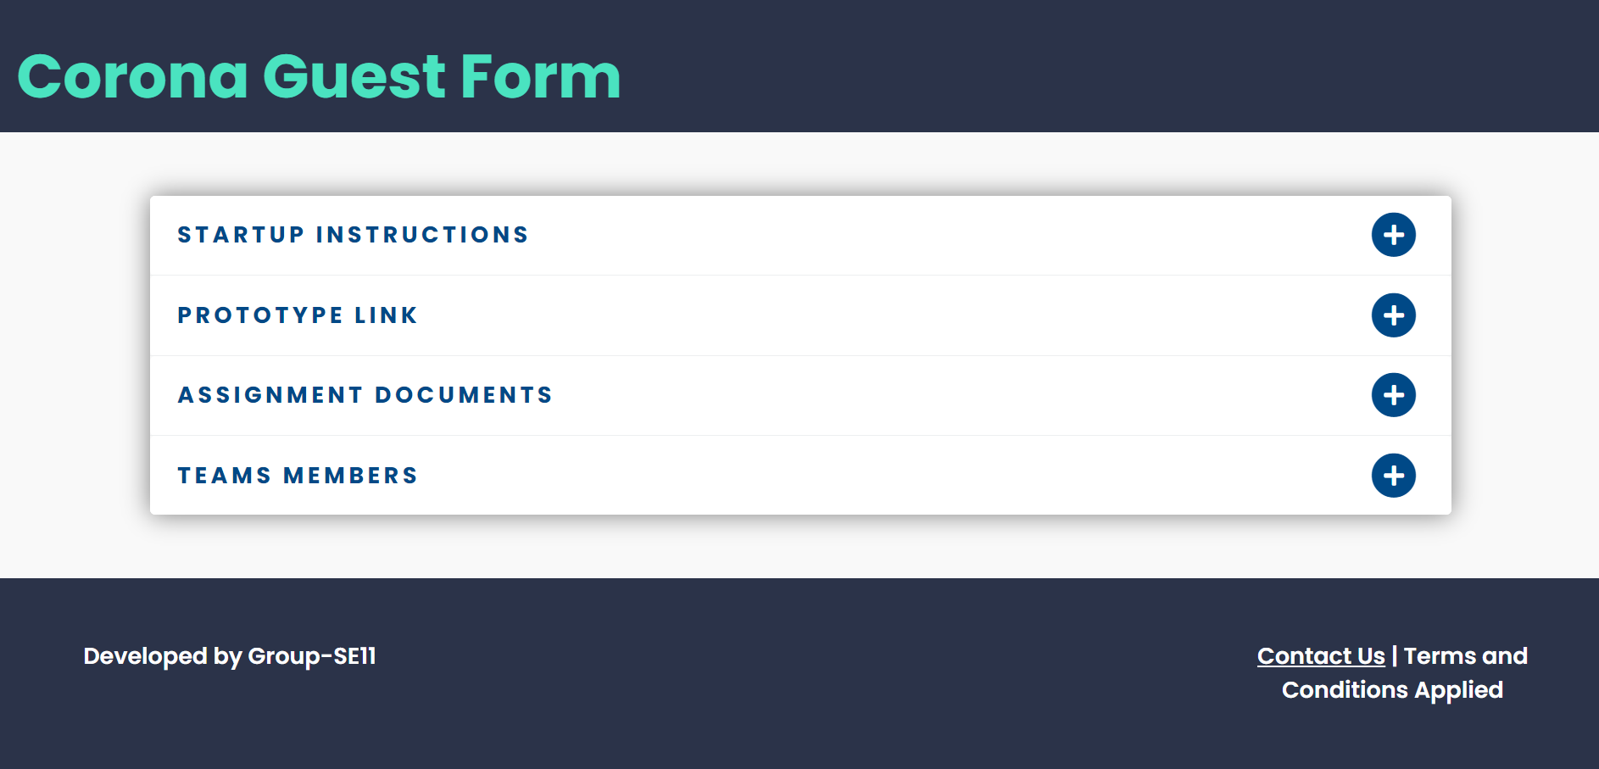

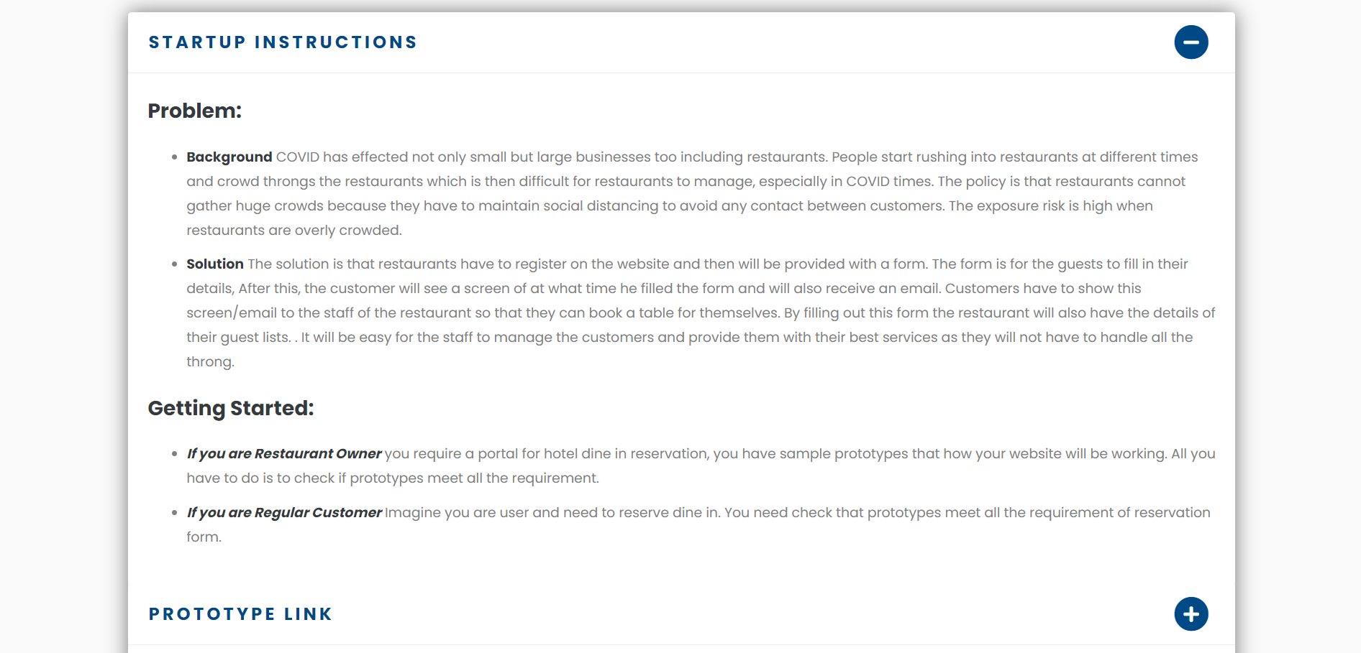

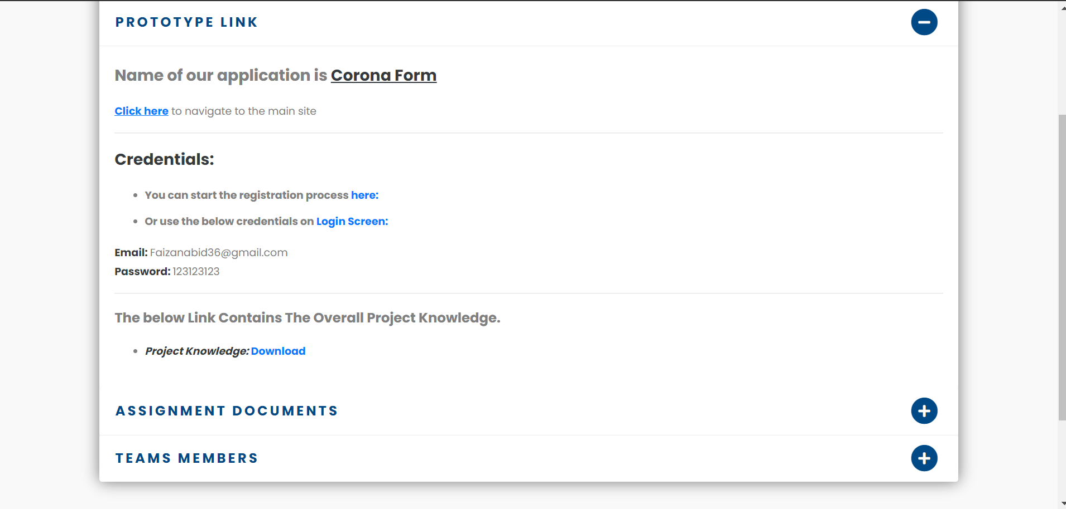

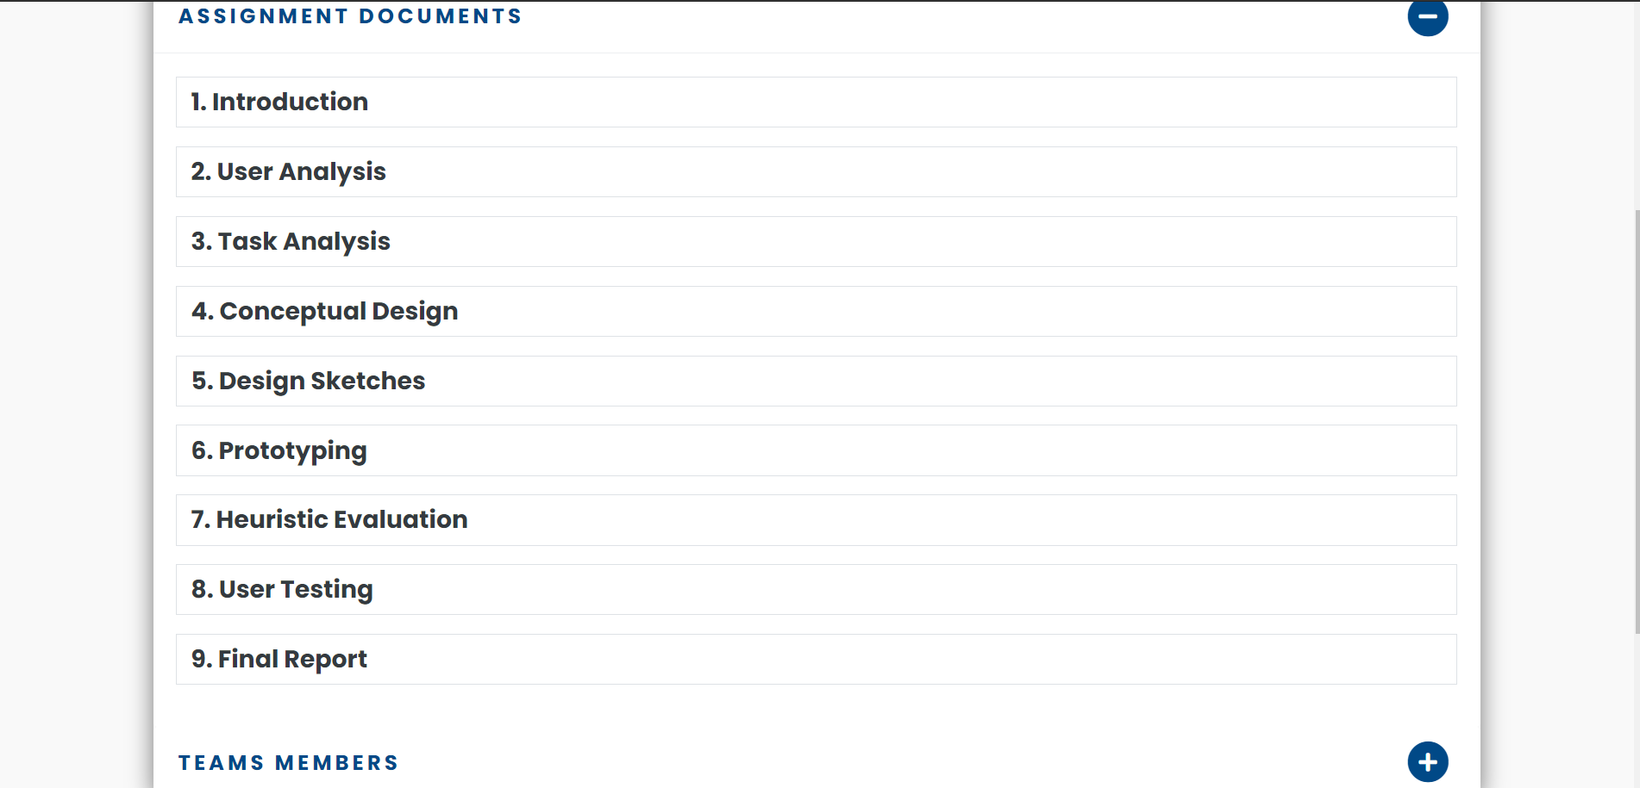

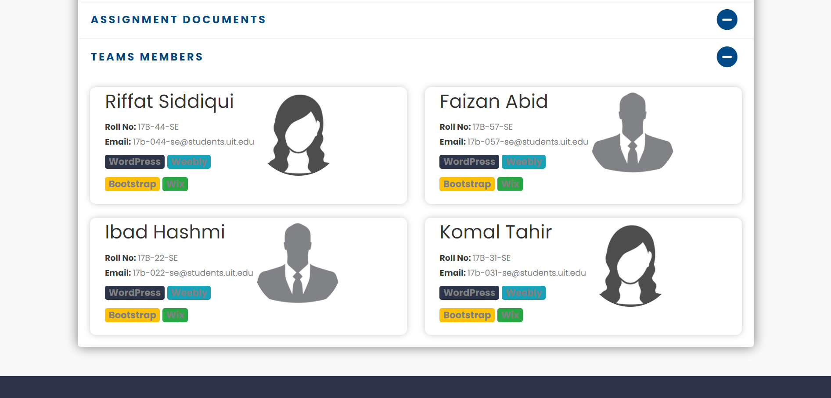

Then we create a Google form for evaluation.

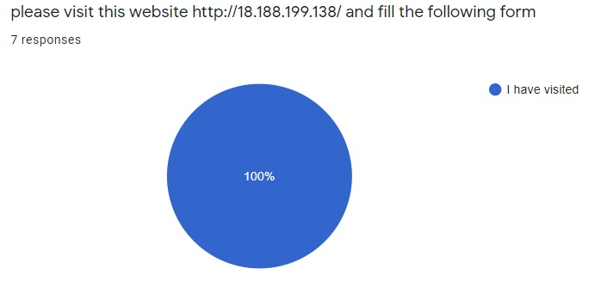

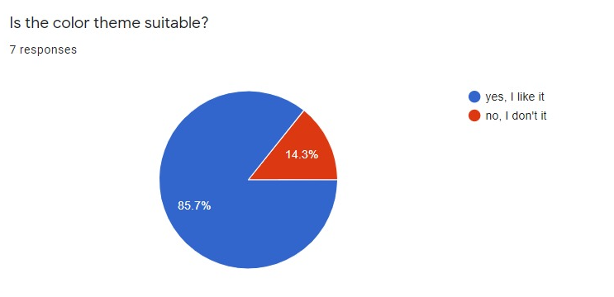

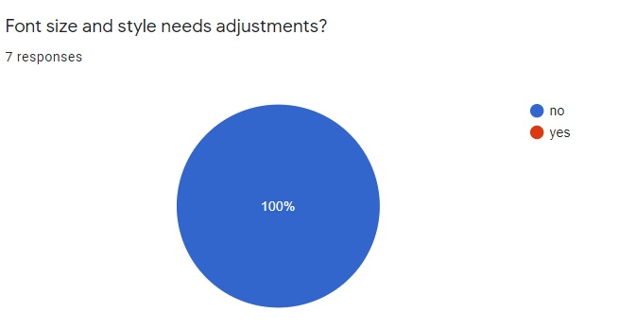

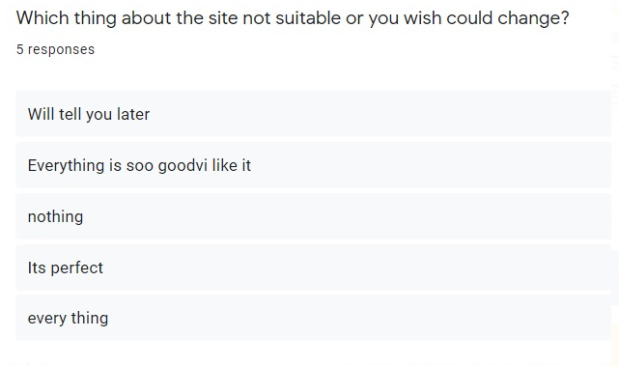

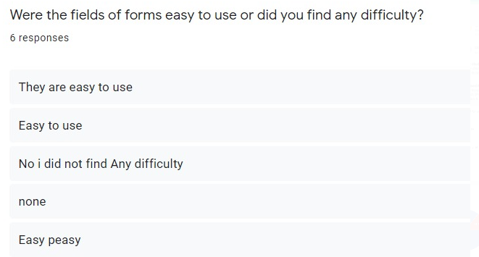

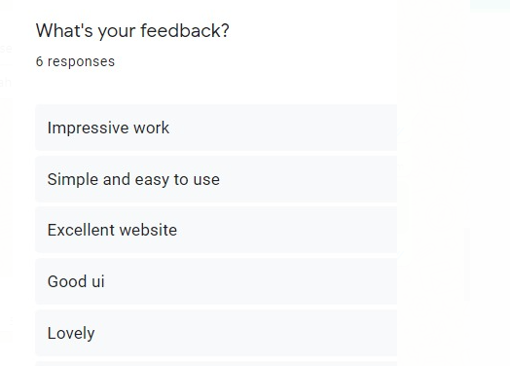

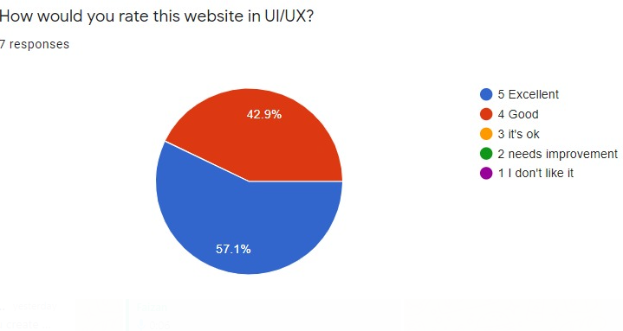After the Google form evaluation we provide check list for further detail about our UI/UX design. Then we figure out most common issue. They are facing with 4/5 user.

### **Website Name: Corona Form**

Website URL: s http://13.59.214.225/

|  |  |  |
| --- | --- | --- |
| **Heuristic** | **Rating**  **(1,2,3)** | **Comments** |

Appearance/Aesthetics – First impression is important – it can make the difference between users staying or leaving your site.

|  |  |  |  |
| --- | --- | --- | --- |
| Primary goal/purpose is clear | ✰ | 3 | Easy to understand. |
| Clean, simple design |  | 3 | Simple and user-friendly UI. |
| Consistent design | ✰ | 2 | Back button missing on registration/login screen. |
| Text and colors are consistent | ✰ | 3 | Yes, they are consistent. |
| Icons are universally understood |  | 3 | Yes, icons are easily understandable. |
| Images are meaningful and serve a purpose | ✰ | 3 | Yes, images are meaningful and serve a purpose. |

Content – Users are at your site for the content – make it easy for them to find and use your site.

|  |  |  |  |
| --- | --- | --- | --- |
| Major headings are easy to understand | 2 |  | Ambiguous heading on registration/login screen. |
| Easy to scan | 3 |  | Yes, scanning QR code. |
| Minimal text/information presented |  |  | Yes, long and descriptive texts are prevented |
| Clear terminology, no jargon | 2 |  | Yes, terminologies are clear. |
| Links are clear and follow conventions | 2 |  | Back button missing on registration/login screen. |
| Help is available on every page | 2 |  | Help documentation is missing. |
| Important content is above the fold | 2 |  | At some point It was missing. |

Navigation – Makes getting around your site easy and takes out the guess work of a user’s visit.

|  |  |  |  |
| --- | --- | --- | --- |
| Consistent Navigation | 3 |  | Back button missing on registration/login screen. |
| Consistent way to return Home | 3 |  | Yes, consistent way to return home page. |
| Limited number of buttons & links | 3 |  | Yes, there are limited button and links. |

Efficiency/Functionality – Following basic rules will keep user frustration to a minimum.

|  |  |  |  |
| --- | --- | --- | --- |
| Website loads quickly | 3 |  | Yes, perfect navigation. |
| Custom 404 errors | 3 |  | Yes, 404 error available. |
| Error messages are meaningful | 3 |  | Yes, validations are perfect. |
| Login is in upper right corner of page | 3 |  | Yes, login button is upper right corner of page. |
| Login is easy to find | 2 |  | We cannot find login button on registration screen. |
| No broken Links | 3 |  | Yes, no broken buttons. |
| User knows if they are logged in/out | 3 |  | Yes, Name of login person is available. |

### Findings and Recommendations:

**Finding 1:**

There is a lack of a customization tutorial for first-time users

**Recommendation:**

We recommend implementing a tutorial to help first-time users understand the customization process and reduce task complexity and confusion.

**Severity:** 2

**Finding 2:**

Use of inconsistent links.

**Recommendation:**

We recommend to use proper back button on every page.

**Severity**: 3

**Finding 3:**

Login button is missing.

**Recommendation:**

We recommend to use login button on registration page. User have to go home page first then go to login button.

**Severity**: 3

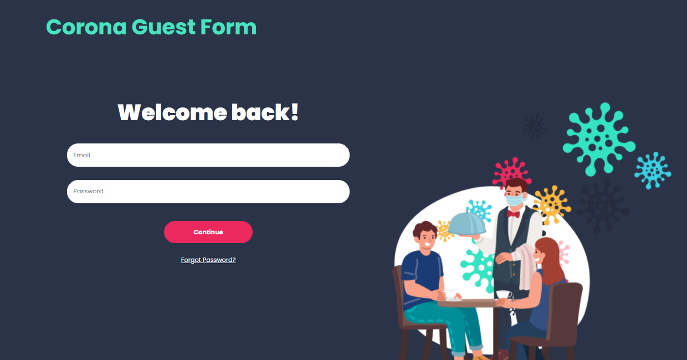

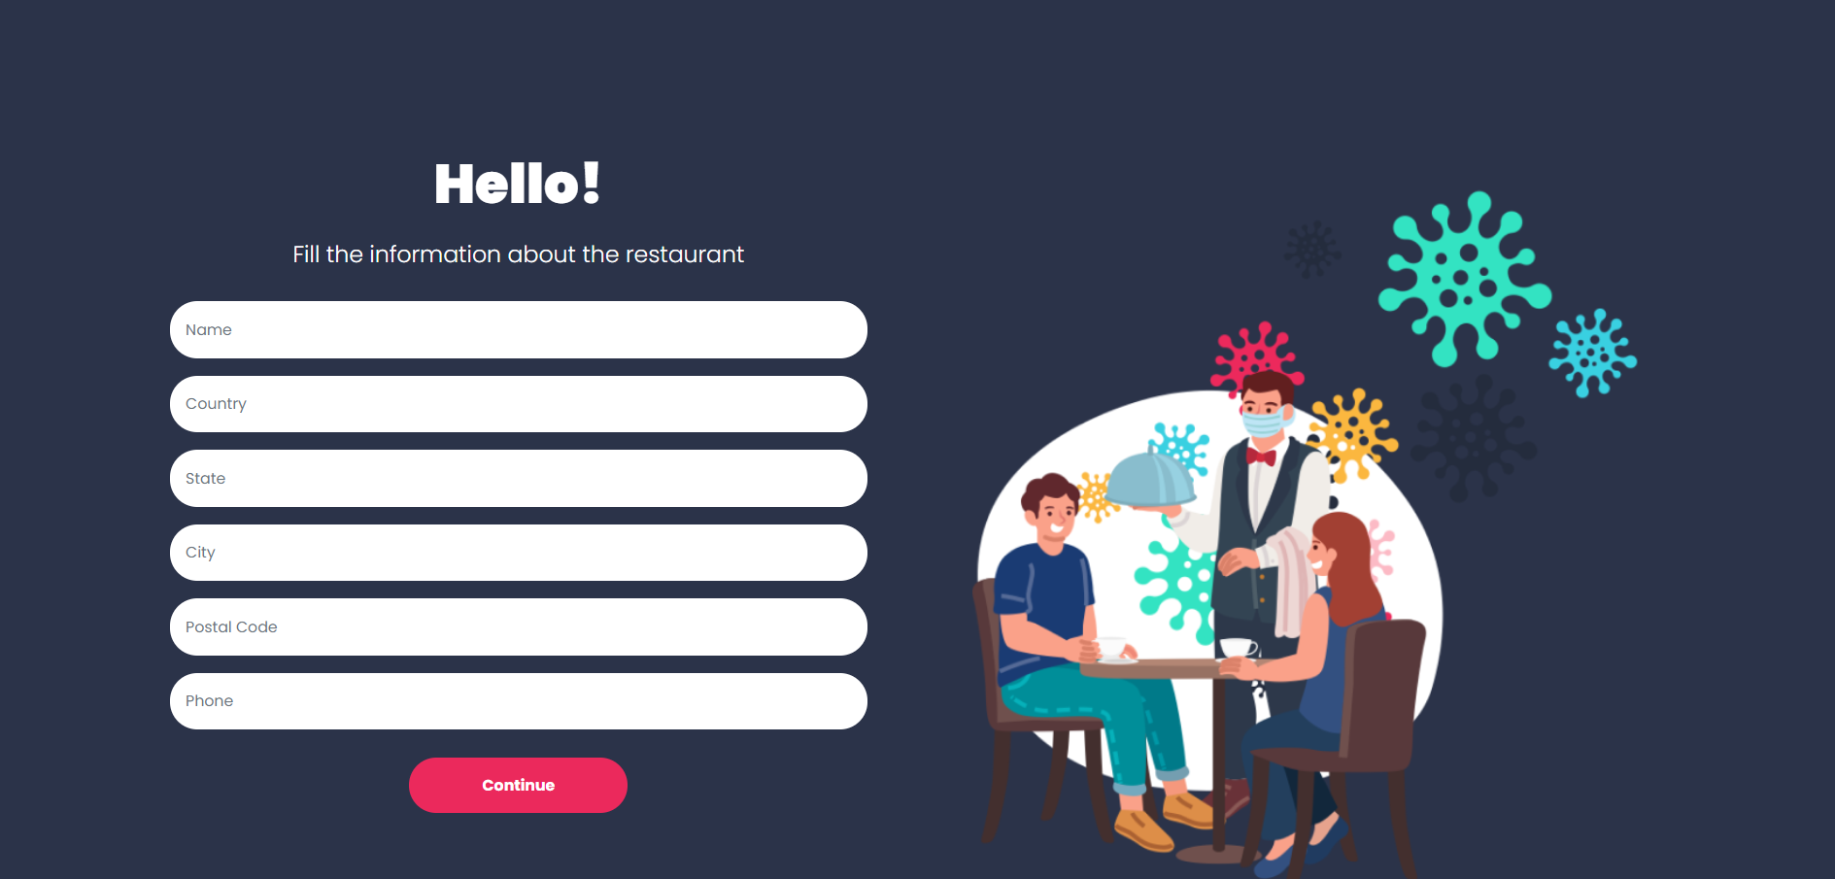

**Conclusion**:

By conducting heuristic evaluations, we were able to analyze the site’s usability, functionality, and design in a standardized structure. Overall, we did not find any major or critical issues of the site but did identify a few areas where links and navigation and basic help could improve in to maximize their user experience and usability. These areas lie in the heuristics of help documentation, visibility of system status, and aesthetic design. We provided recommendations of implementing a tutorial for first-time users, improving the visibility of the site’s photo editing features, highlighting selected features to show users what they have selected, making help documentation easier to find, and improving the site’s design to minimize distraction.

# **User Testing & Prototype Revision #2:**

## Usability Test Report

**Executive Summary:**

For this report, we conducted Usability test of **CORONA FORM** Usability test allow us to analyze the usability and functionality of the site in a standardized way. We performed individual heuristic evaluations and then met together to discuss and combine our results. The system was evaluated and ranked according to user testing heuristics and severity rating scale of 0-3. After discussing our noted usability issues, we prioritized our findings by severity and developed the following series of findings and recommendation.

**Introduction:**

Due to COVID, restaurants are still open for dine in but for limited time. People start to rush into restaurants at different times and crowd throngs the restaurants which is then difficult for restaurants to manage them especially in COVID times. Customers need to wait for long hours for their turn. Thus, by utilizing technology we overcome the problem (crowd and sops maintenance).

**Roles:**

The roles involved in a usability test are as follows.

**Restaurant owners:**

* Register Restaurant.
* Register/login.
* Retrieve Guest list.
* Provide customers with space available.
* Download brochure.
* Receive QR code.

**Customers:**

* Fill provided form by restaurants.
* Scan QR code.
* Receive confirmation email.

## Focus of Evaluation:

To first start off, we narrowed down. We wanted to evaluate. Looking at the site’s main functions, we focused on evaluating **CORONA FORM** ability to create better and customize screens.

**Goals:**

* Test website concept with targeted audience.
* Identify bugs and issues with the platform.
* Reveal friction points and confusing experience.

**Participant profiles:**

Participant which are involve in usability testing:

|  |  |  |  |  |  |
| --- | --- | --- | --- | --- | --- |
| **Users** | **Age** | **Gender** | **Education** | **Occupation** | **Place** |
| Hassan | 21 | Male | Undergraduate | Freelancer | Online meeting |
| Yumna | 24 | Female | Masters | Web developer | Online meeting |
| Farhan | 20 | Male | Undergraduate | Web developer | Online meeting |

### Testing Setup, Moderation & Post-Task Questions:

**Tasks:**

List the tasks you asked your participants to perform here.

* Create an account and login.
* Edit your profile.
* Find specific content, page, button, etc.
* Retrieve Guest list.
* Fill provided form by restaurants.
* Complete an entire task from start to finish (for example: upload a photo, request a quote, purchase a product, etc.)

### **Post-Test Questions:**

1. Are all the dropdowns on this screen sorted correctly? Alphabetic sorting is the default unless otherwise specified.

This is not applicable in our application.

1. Is all date entry required in the correct format?

The dd/mm/yyyy format is used when the user fills the form

1. Have all pushbuttons on the screen been given appropriate shortcut keys?

User can navigate to all the buttons and links one by one using the tab key.

1. Do the shortcut keys work correctly?

Tab is the only shortcut key used which working correctly.

1. Have the menu options which apply to your screen got fast keys associated and should they have?

Not Applicable.

1. Does the TAB order specified on the screen go in sequence from top left to bottom right? This is the default unless otherwise specified.

Tabs are not used in our application.

1. Are all read-only fields avoided in the TAB sequence?

Not Applicable

1. Are all disabled fields avoided in the TAB sequence?

Not Applicable

1. Can the cursor be placed in the micro help text box by clicking on the text box with the mouse?

Not Applicable

1. Can the cursor be placed in read-only fields by clicking in the field with the mouse?

No, it can’t be placed

1. Is the cursor positioned in the first input field or control when the screen is opened?

The position of cursor is not defined when the screen is loaded.

1. Is there a default button specified on the screen?

No default button is used

1. Does the default button work correctly?

Not Applicable

### Finding and recommendation:

**Finding 1:** Use of inconsistent links.

**Recommendation:** It was recommended to us that we can create a back link or button with the label to navigate us to different screens.

**Finding 2:** There is no portal for users to write their queries to the admin, how do I contact the team?

**Recommendation:** It was recommended to us that we should create contact us page so that customers can write their queries to the admin if they are facing any problem.

**Conclusion:**

With the successful conducting of usability test report, we were able to analyze the site’s usability, functionality, as well as design in a standardized structure. No major or critical issue of the site but did identify a few areas where navigations could improve in to maximize their user experience and usability.

## Updated Prototype

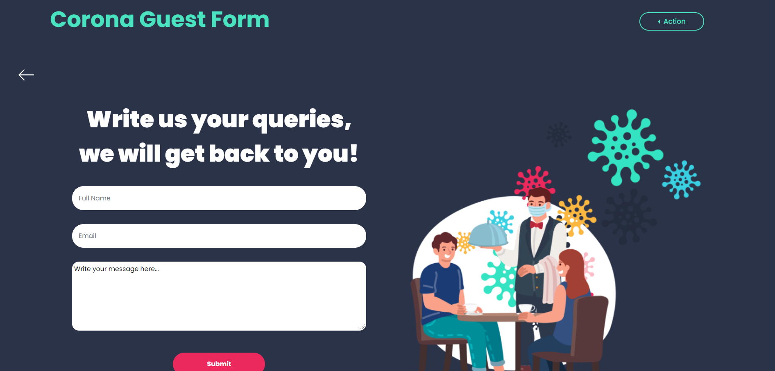

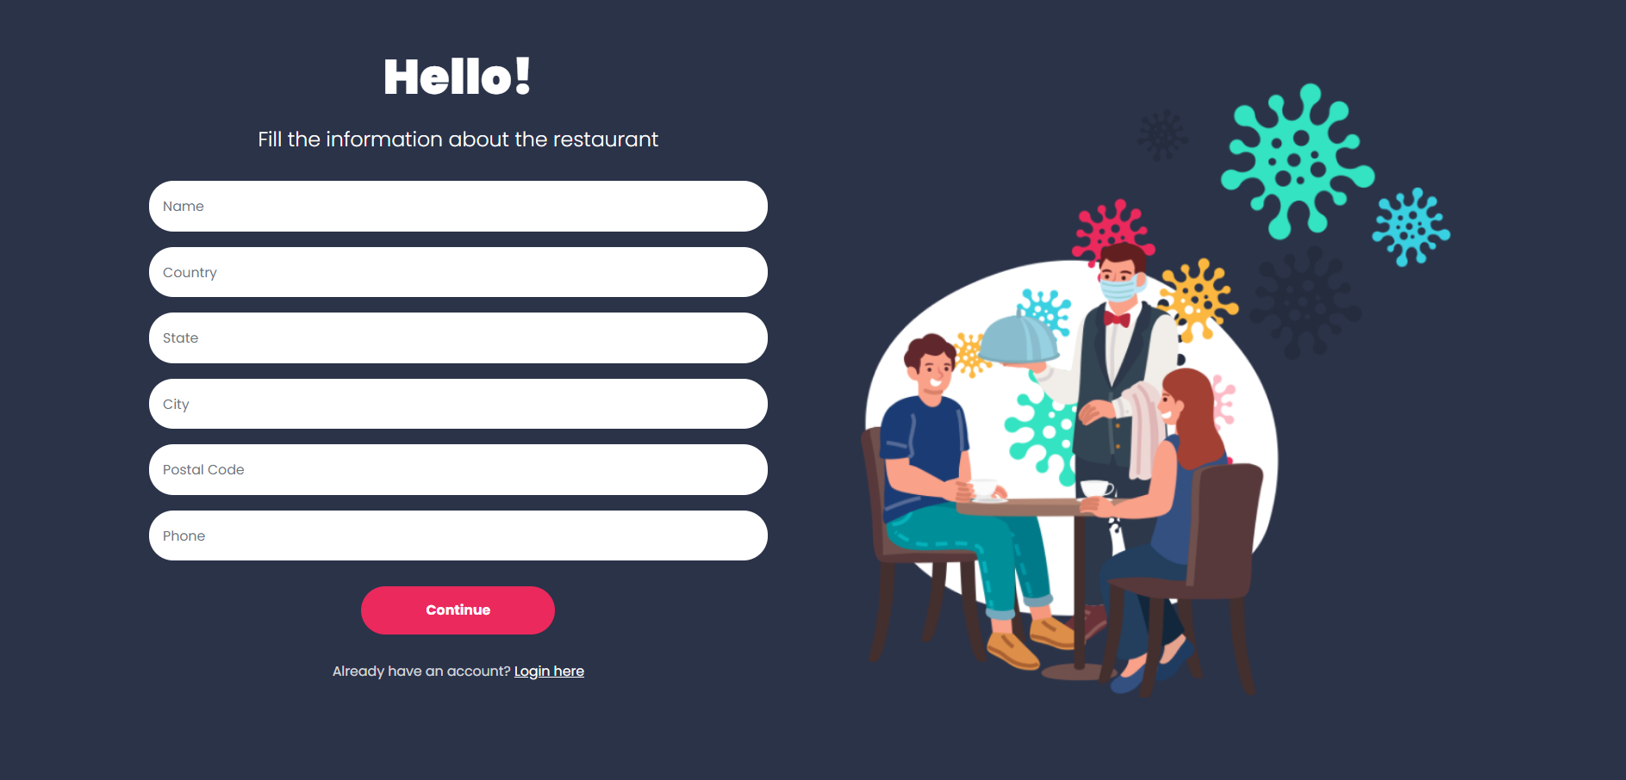

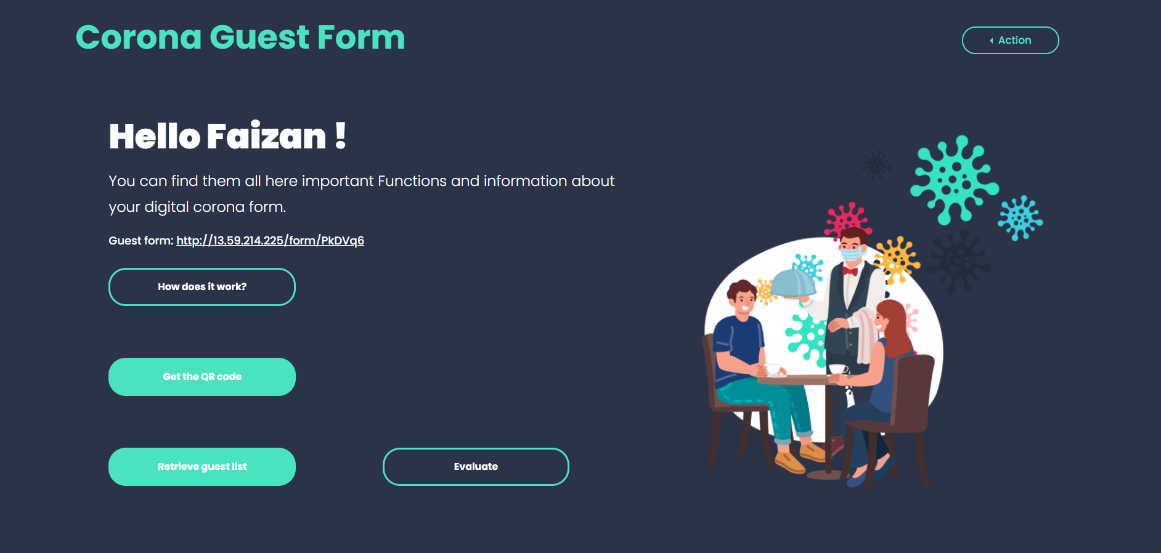

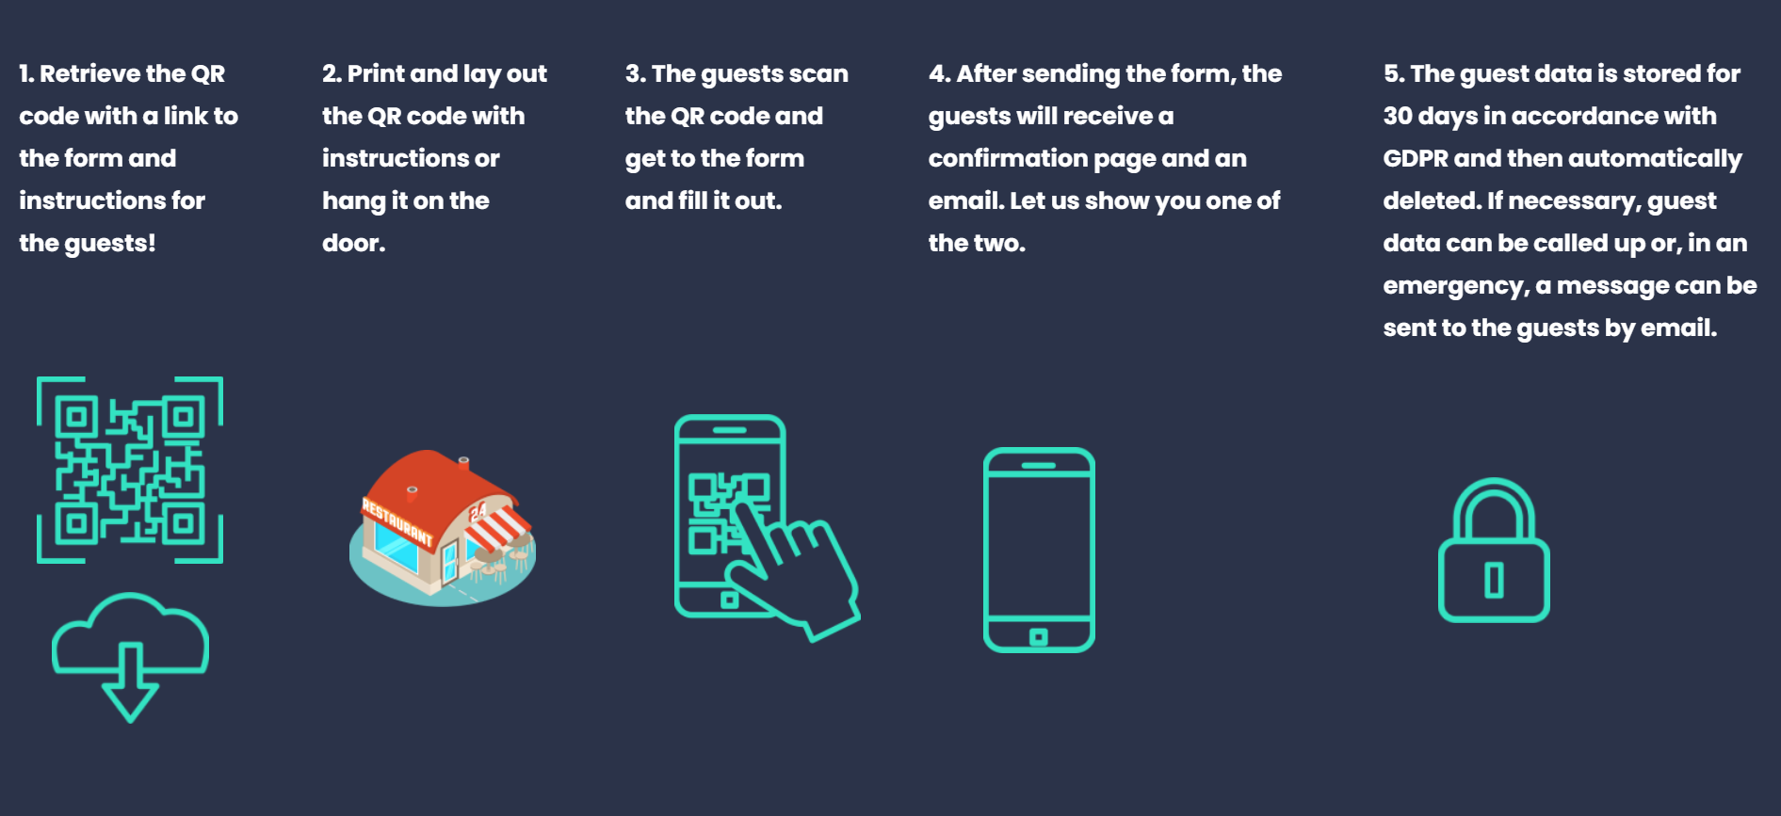

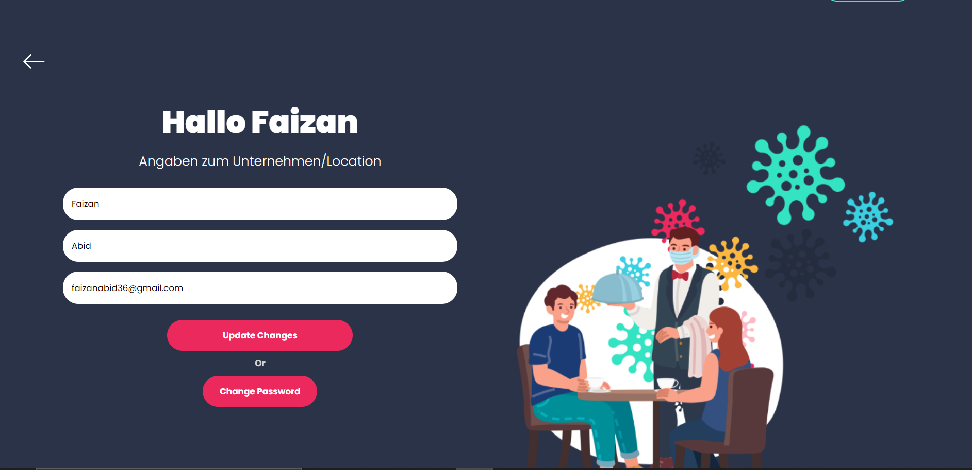

# **Roles and Tasks**

|  |  |  |  |
| --- | --- | --- | --- |
| **Team Members** | **Roll no.** | **Roles** | **Tasks** |
| Faizan Abid | 17B-057-SE | * Project Manager * Web designer * Software Engineer. * Test Engineer | Web Development, project managing, User testing, Prototype Revision, Testing and debugging. |
| Riffat Siddiqui | 17B-044-SE | * Project Manager * Designer * Software Engineer. * Architect | Project managing, Conceptual Designs, Metaphors, Content Diagram, Literature Work, Evaluation. |
| Ibad Hashmi | 17B-022-SE | * Software Engineer * Test Engineer * Architect | User and Task Analysis, Task Scenarios, Computer based prototyping, Heuristic Evaluation. |
| Komal Tahir | 17B-031-SE | * Business Analyst * Architect * Test Engineer. * Designer | Problem Definition, Usability Requirements, Design Sketches (Story Boarding), Paper based Prototyping, Literature work. |